**INHA UNIVERSITY IN TASHKENT**

**DEPARTMENT OF CSE**

**SPRING SEMESTER 2020**

**SOC 2110 - Internet Programming**

**Submitted by**

|  |  |  |  |
| --- | --- | --- | --- |
| **Team Leader:** | **Student name:**  **Makhsudov Jasur** | **Student ID**  **U1810200** | **Section**  **2** |
|  | Juraeva Sabokhat | U1810149 | 2 |
|  | Mardonova Mubina | U1810151 | 2 |
|  | Isroilov Tukhtamurod | U1810171 | 2 |
|  | Mukhamedov Bekzod | U1810203 | 2 |
|  | Talipova Zilola | U1810043 | 3 |



**Team:** Perfect Mix

**Business Scenario:** Restaurant

**Company Name:** Fantasy

**Motto:** Better food better mood

**Host**: <http://perfectmix.uz/>

**GitHub:** <https://github.com/iuthub/ip-group-project-perfect-mix>

**Web Application**

|  |  |  |
| --- | --- | --- |
| № | Content | Page |
|  | Content | 3 |
|  | Look and Feel | 5 |
|  | Input Validation | 17 |
|  | Database | 19 |
|  | Server-side Framework Laravel | 20 |
|  | Client-side Scripting | 37 |
|  | GitHub and Hosting | 39 |
|  | Conclusion | 41 |

**Content**

Nowadays it is very important to book a table before going to a restaurant. This is due to the avoidance of inconveniences such as lack of space and waiting. At the same time, it has become a habit to order food while sitting at home. Especially, people who have no time or wish to cook may order what they want via believable website or app.

So, after receiving the group project task, we started discussing all the requirements, did first brainstorm with team members and decided to create a website of restaurant. And we created a website of restaurant which we named “Fantasy” with our “Perfect Mix” team that gives consumers a lot of opportunities. Our main goal was to create a web site that could attract customers and provide good service to them.

Thus, in order to make well-designed site and to improve the service, we needed following requirements:

1. Restaurant’s landing page which contains short information with relevant photos of our restaurant;
2. Product/Service page that is in our case foods or menu which defining the traditional meals of different countries;
3. Registration and Log in pages that are required to fill from users for having opportunity to use all functions;
4. Ordering food and booking table beforehand that user can easily submit their order and it can be accepted or cancelled by the administration;
5. Process order that is visible only for Admins, they can process submitted orders by assigning fulfilled or cancelled statuses to them;
6. Contact Us Page that clients can leave their feedback by submitting the message to website mail which will received by administration.

Consequently, we have made the exquisite, colorful site which is easy to understand by using mentioned requirements above.

For example, everyone can visit our website and may get information about restaurant, its menu, how to order food or table and they should register for becoming our clients. However, unregistered guests cannot order food/table and contact us. Main reason is that booking and sending message require some details and data of user. So, if they want to order they should register first. Registered users may easily log in after verifying email, then just enjoy by ordering foods, booking tables beforehand, receiving vouchers, seeing all ordered foods by them and of course edit their profile details.

Moreover, there are 3 types of vouchers that is a discount of for next payments:

1. **None:** Status 0% - no discount for any food to people who didn’t pay more than $300 afore;
2. **Silver:** Status 3% - discount for any food to people who paid more than $300 afore;
3. **Premium:** Status 5% - discount for any food to people who paid more than $500 afore;
4. **Gold:** Status 7% - discount always for any food to people who paid more than $700 afore;

Admin user can add new cuisine and its types of foods, see lists of ordered food/table, delete/edit foods from menu, see all users and their data, accept or cancel orders of food/table and add new admin as well.

**Look and Feel**

In our project, we designed our web page in [figma](https://www.figma.com/file/ZgYYiswS4RPdWq1shzbp0m/Untitled?node-id=128%3A0) art board, then we started coding with our team.

In the figure1 and 2, restaurant web pages which have been designed in the [figma](https://www.figma.com/file/ZgYYiswS4RPdWq1shzbp0m/Untitled?node-id=128%3A0) art board

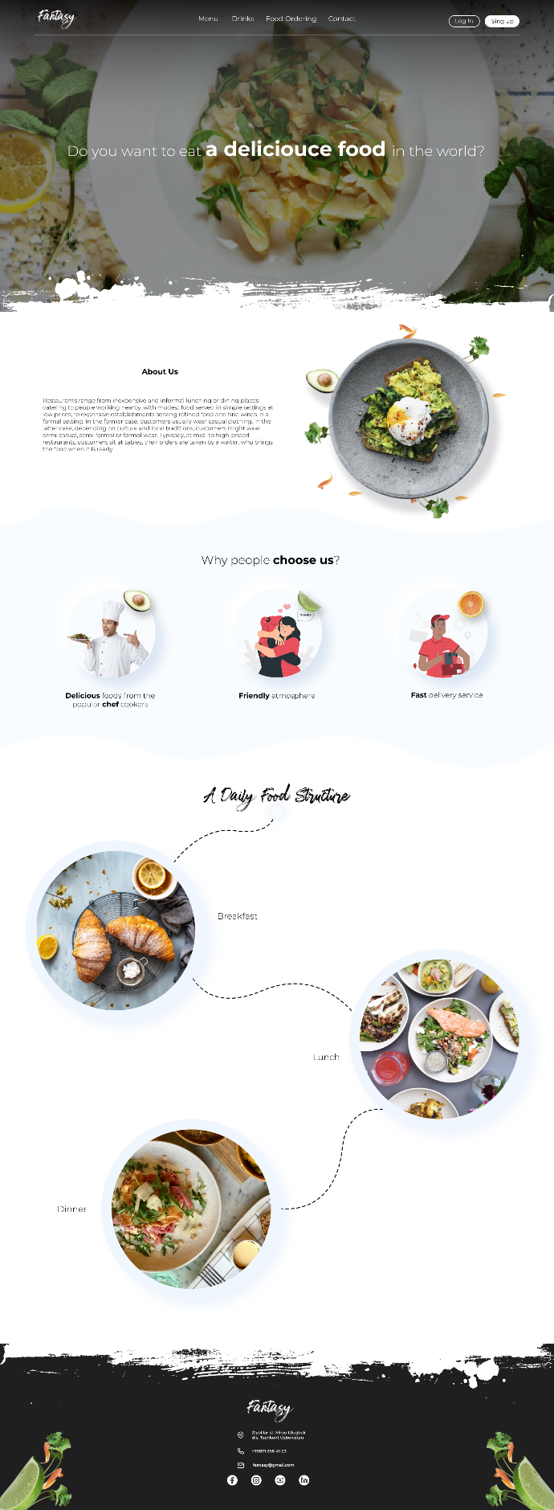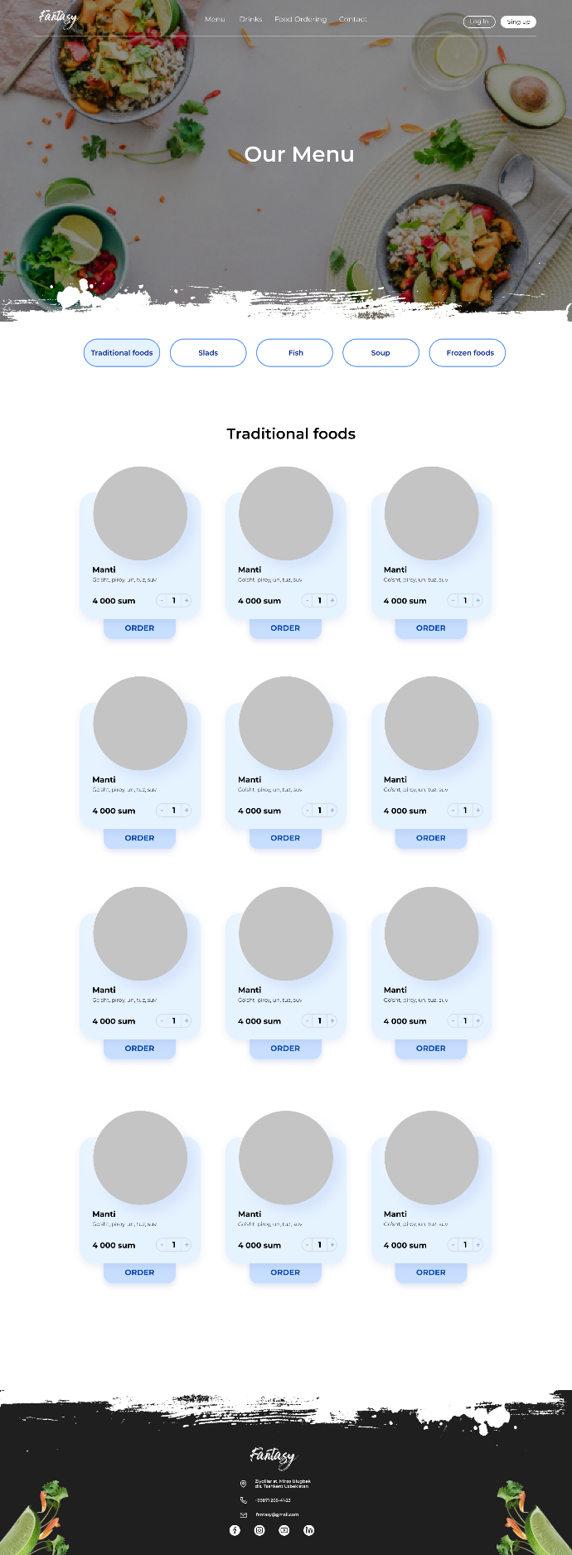

Figure 1

Figure 2

At first, mainPage and Layouts folders, which have index.blade.php and header.bleade.php files are created.

Figure 3

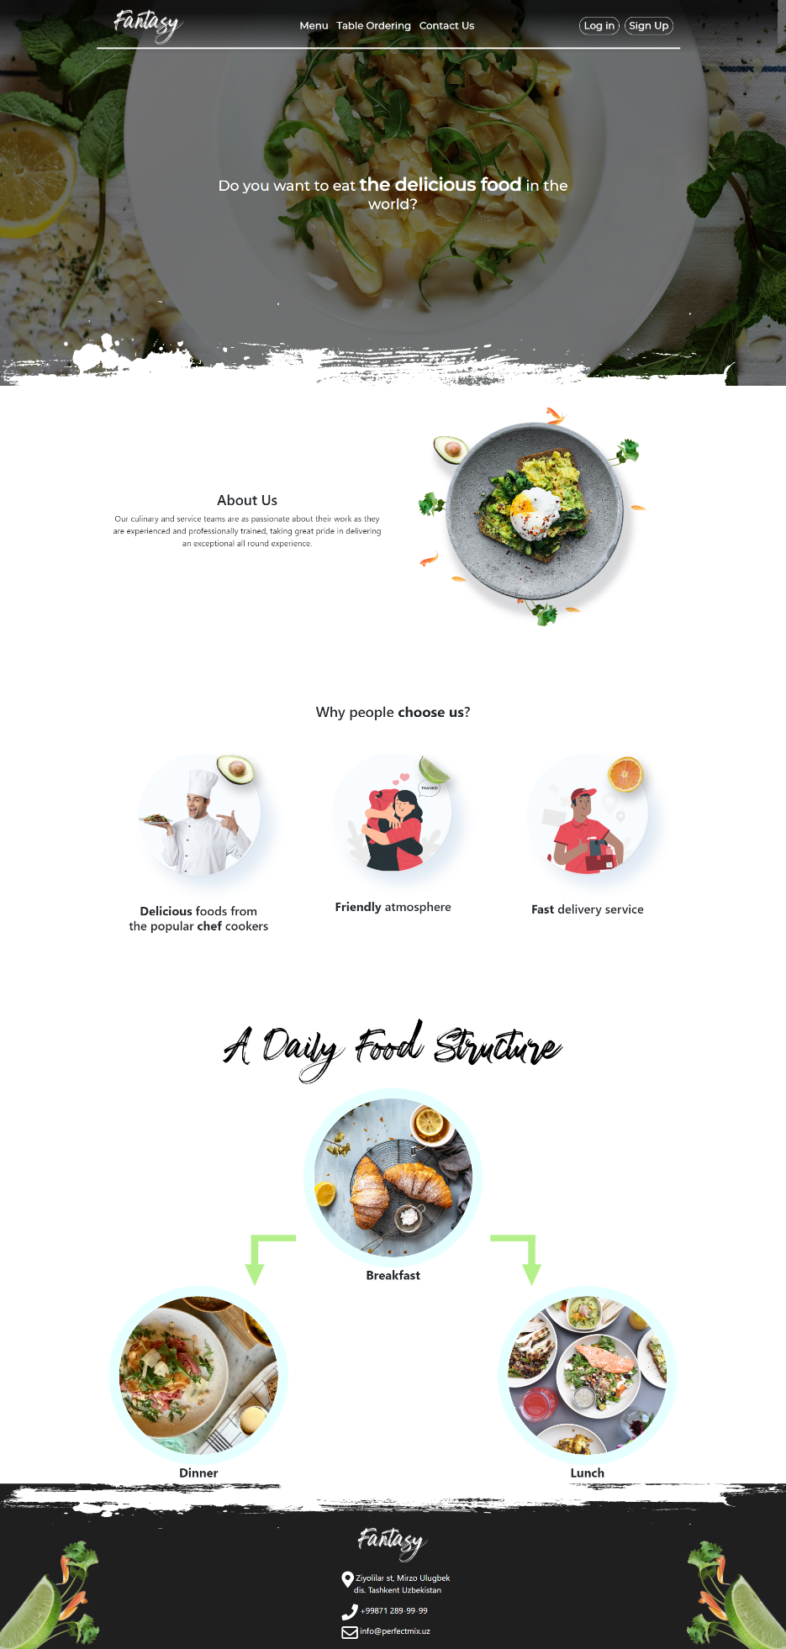

*It’s the main page of the website, in this page, user can know about the restaurant, why they should choose this restaurant, which is named Fantasy.*

*Moreover, there are log in and Sign Up buttons for registration. If user want complete other process such as ordering food and table, they should create the profile.*

**Sign Up** button is clicked user can see this view.

Figure 4

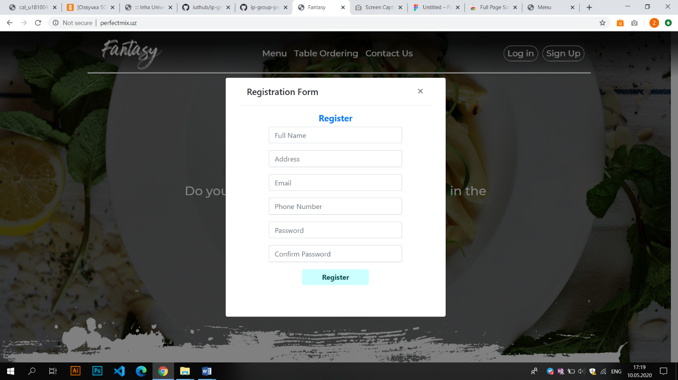

*The popup registration page allows the uses to write their personal information which will be utilized ordering process.*

* *Full name of user*
* *Right address for delivering purpose*
* *Email*
* *Phone Number for contacting with client*
* *Password*

After creating profile, user can complete other process, or user have profile they can log in.

In figure 5, you can see Log In page.

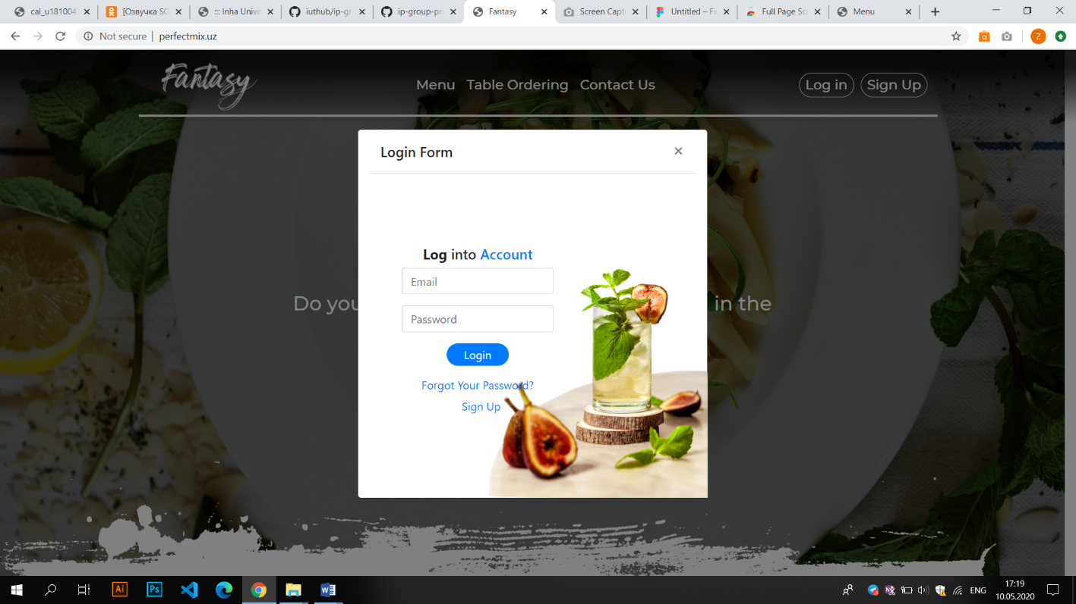

Figure 5

After Login button is clicked, user can see this page in figure 6.

Figure 6

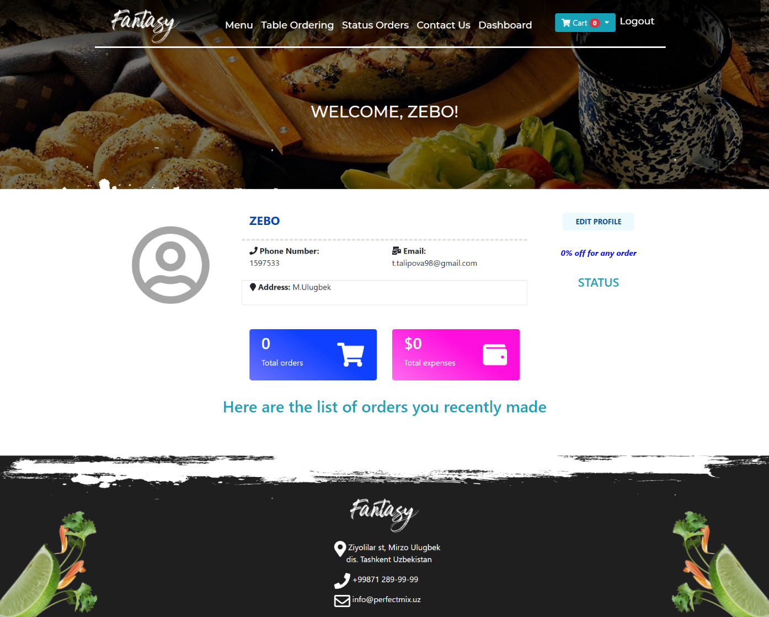

*It’s shows dashboard page when user has successfully log in. Dashboard page gives personal information, which is inputted in registration process, and total orders and total expenses. In addition, user can edit personal information if there is a mistake.*

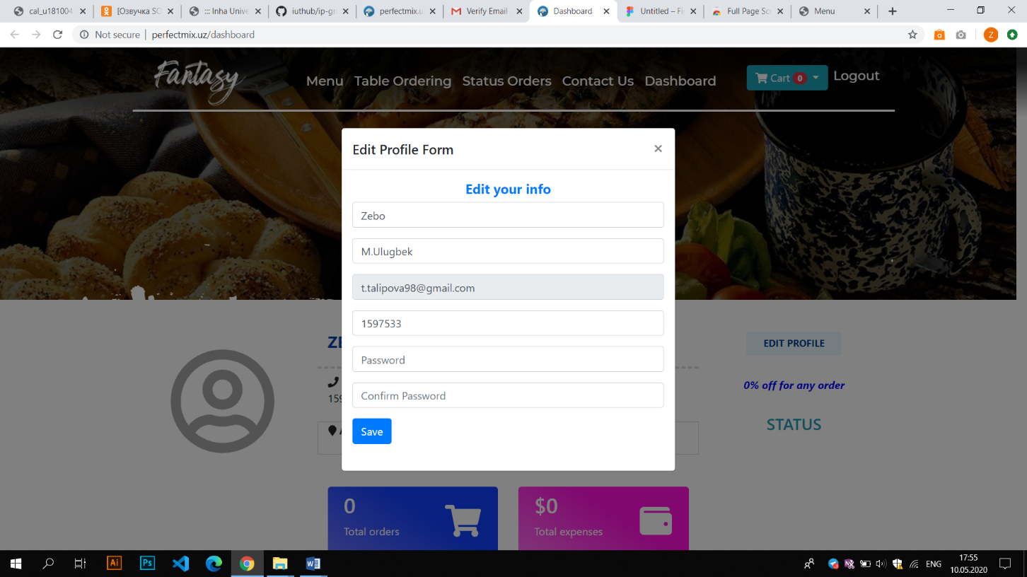

Figure 7

Clicking on **Edit button** in figure 7. *In the popup page, user can edit personal information*

**Menu page**

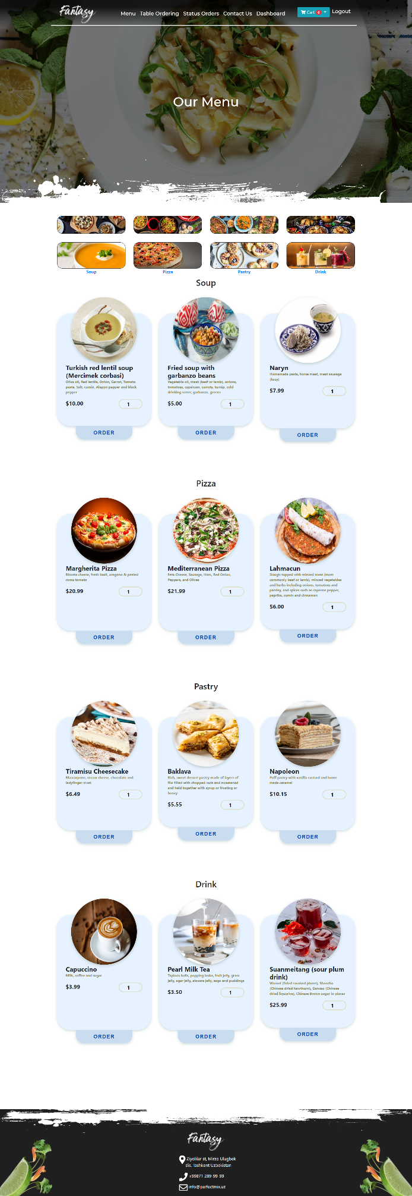

In menu page, there are different sections which is Soup, pizza, Pastry and drink. User can order the food to depending on his or her taste.

In addition, there is Italian, Chinese, Turkish and Uzbek cuisine Section.

If we look at card of each food, user can take information about food name, description and cost.

If user hover on little adding box which is located next to the cost, user can add number of food and also can decrease it.

Order button allows ordering the food.

**Ordering process.**

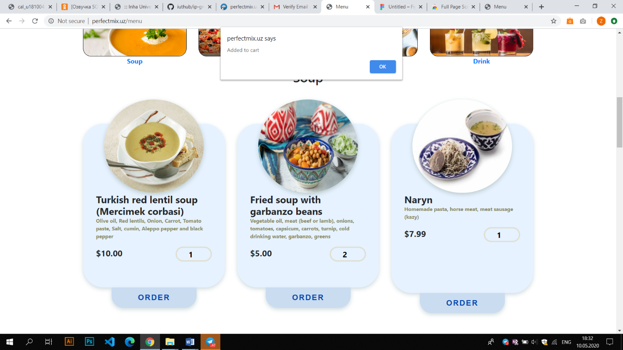

*Clicking on ordering button, webpage shows “added to card” popup page.*

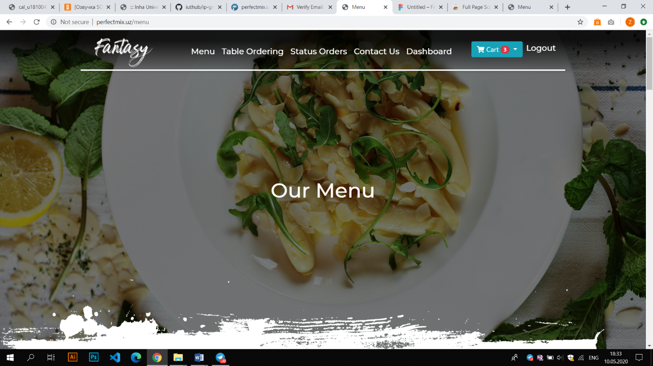

*Top of the webpage shows to user number of selected food*

*Clicking on card section, it’s display ordered food with all information.*

*User click on order button here all ordered food will be in pending food table*

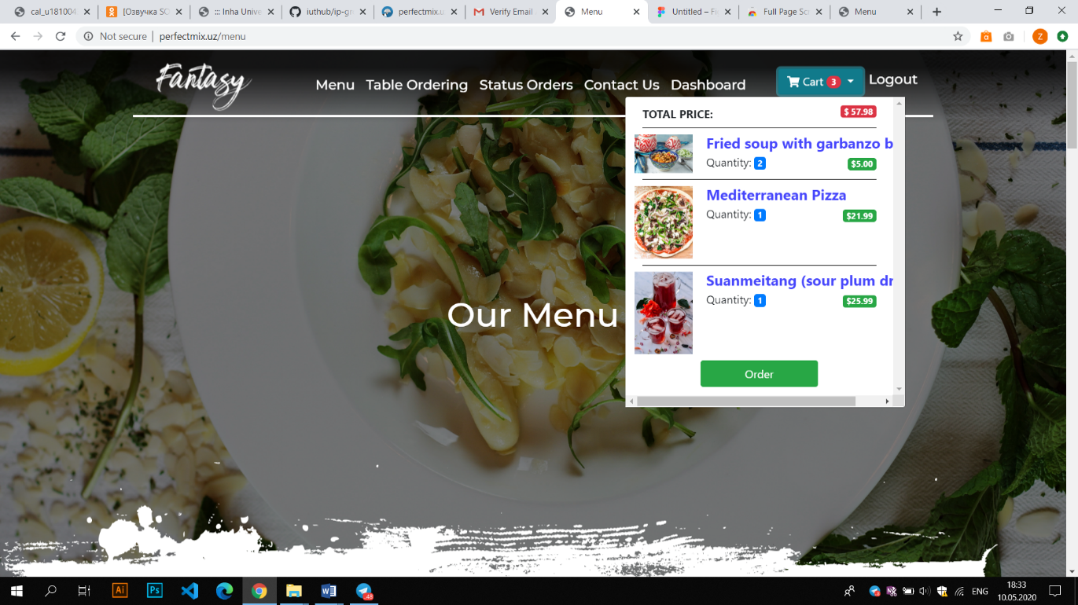

*Pressing on Order button, page opens for user this page*

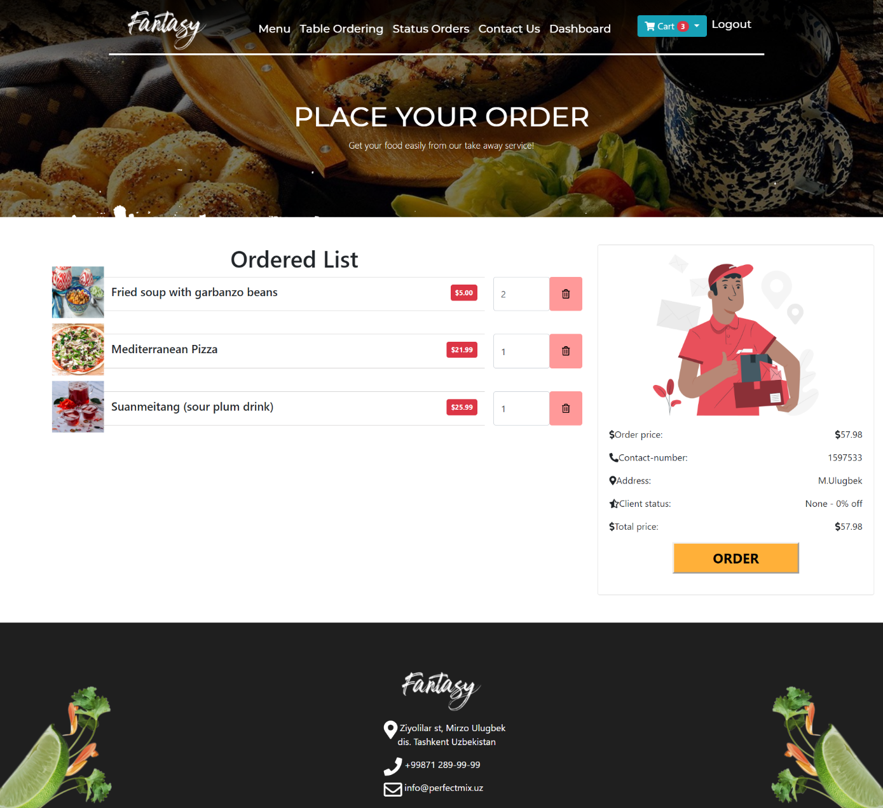

It allows the user deleting the food or editing the number of food. Then user can order the food

*Moreover, If user want to order table, details of table should be inputted in this page.*

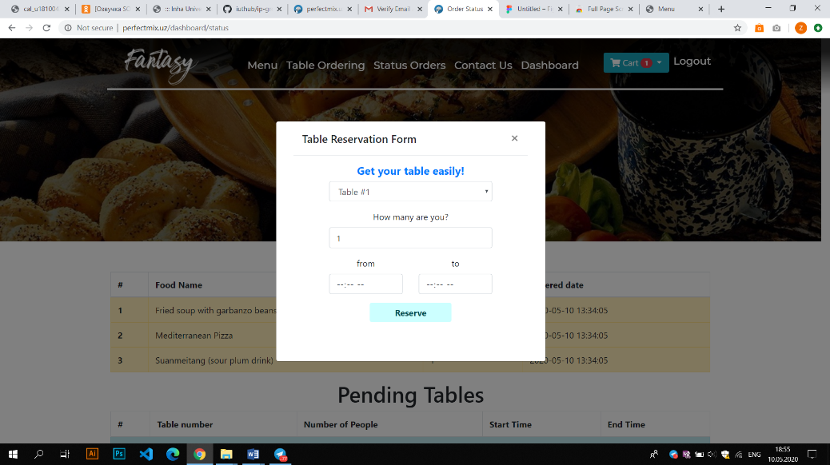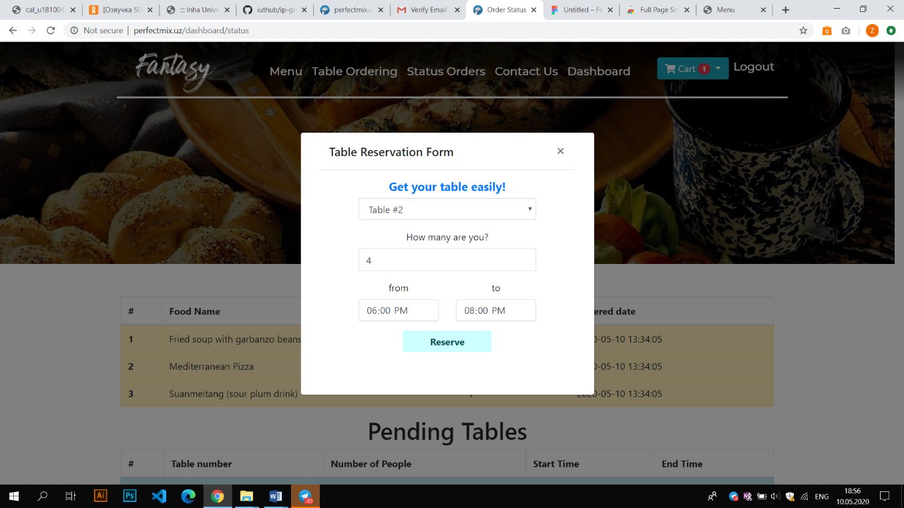

*All ordered table and foods are in pending page*

**Status Orders page**

*All ordered food are in pending food table*

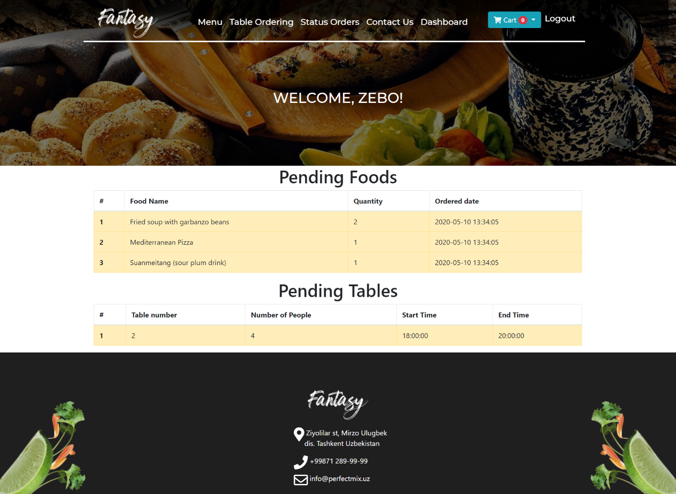

**Contact us Page**

*Clients can write their request and suggestion to restaurant administration service.*

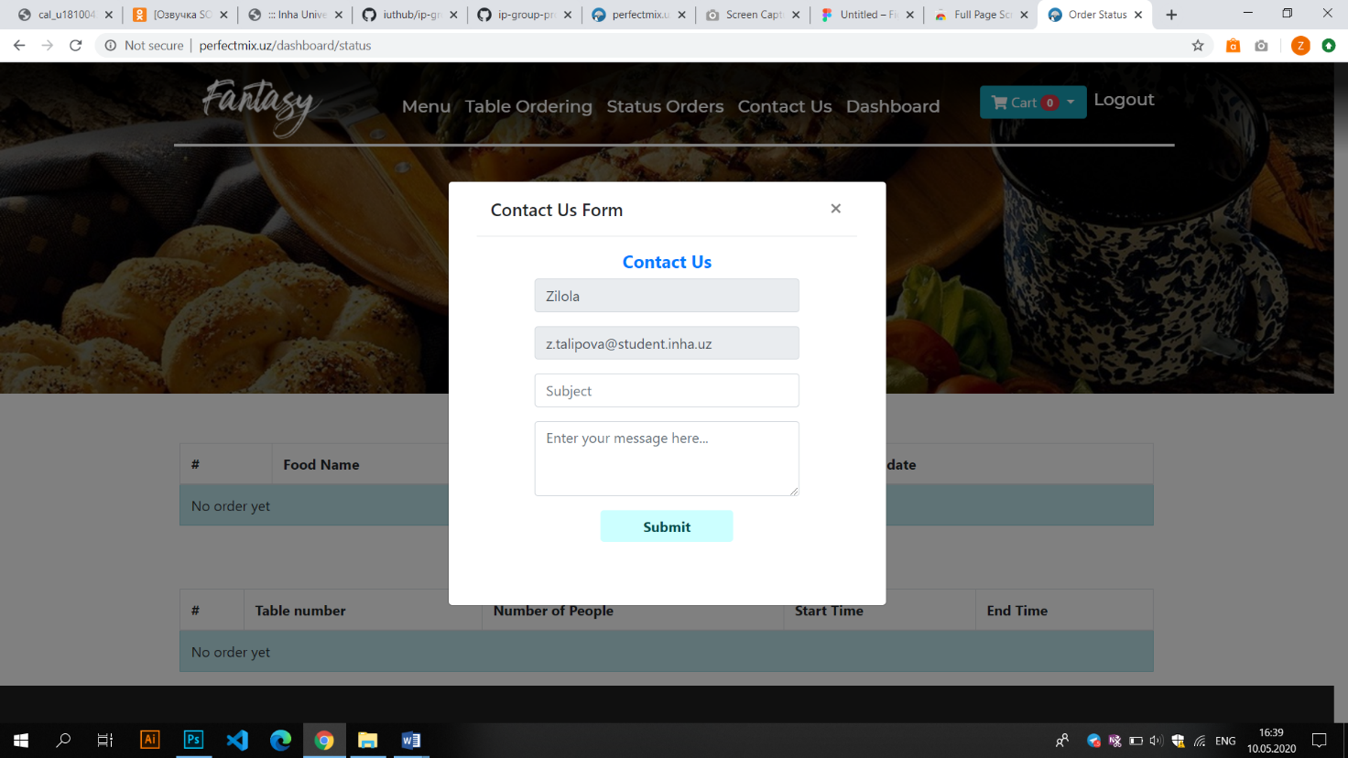

**Admin Page**

If you logged in as admin, you should see this page in dashboard section

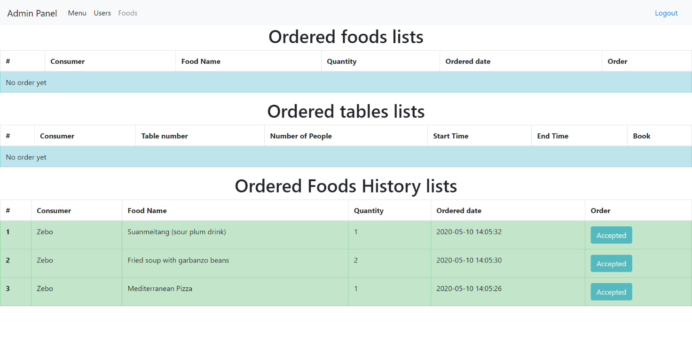

*When admin open dashboard section, admin can take ordered food list, also there is history list which shows accepted foods*

In the User panel, admin can add, delete and edit the user.

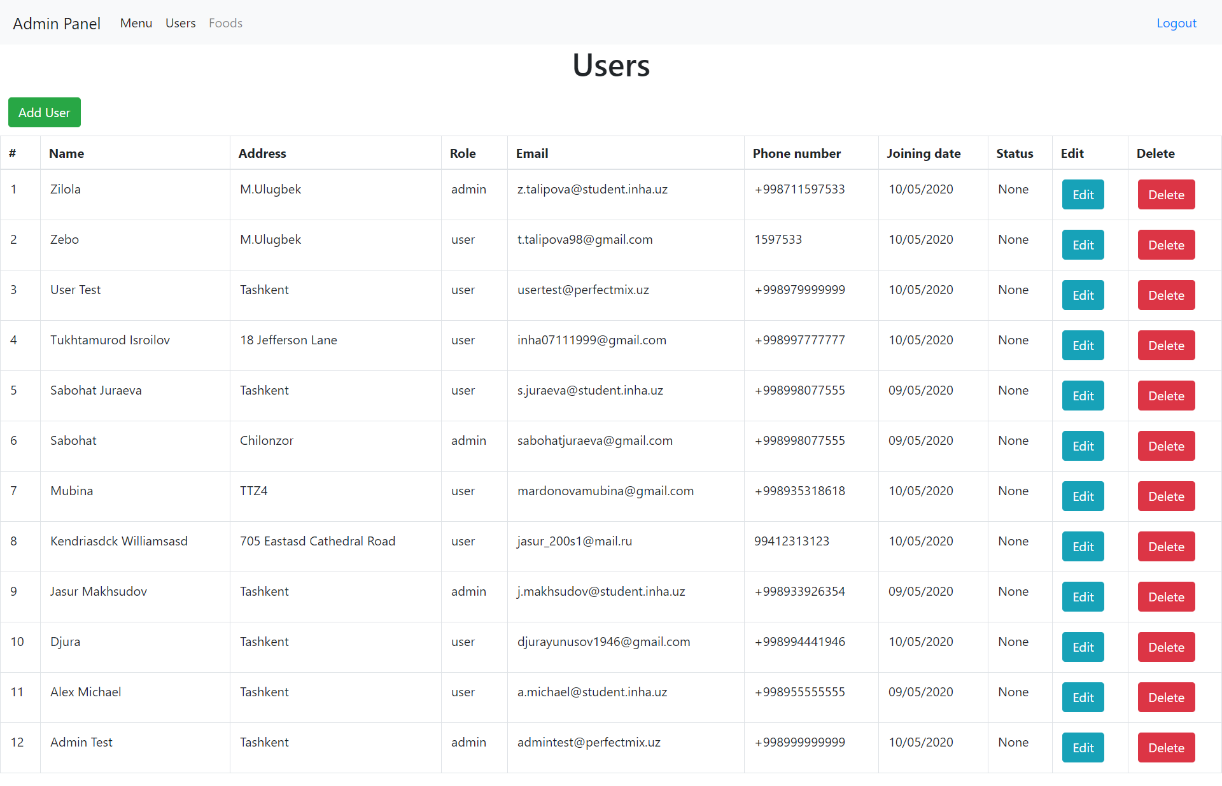

Editing user

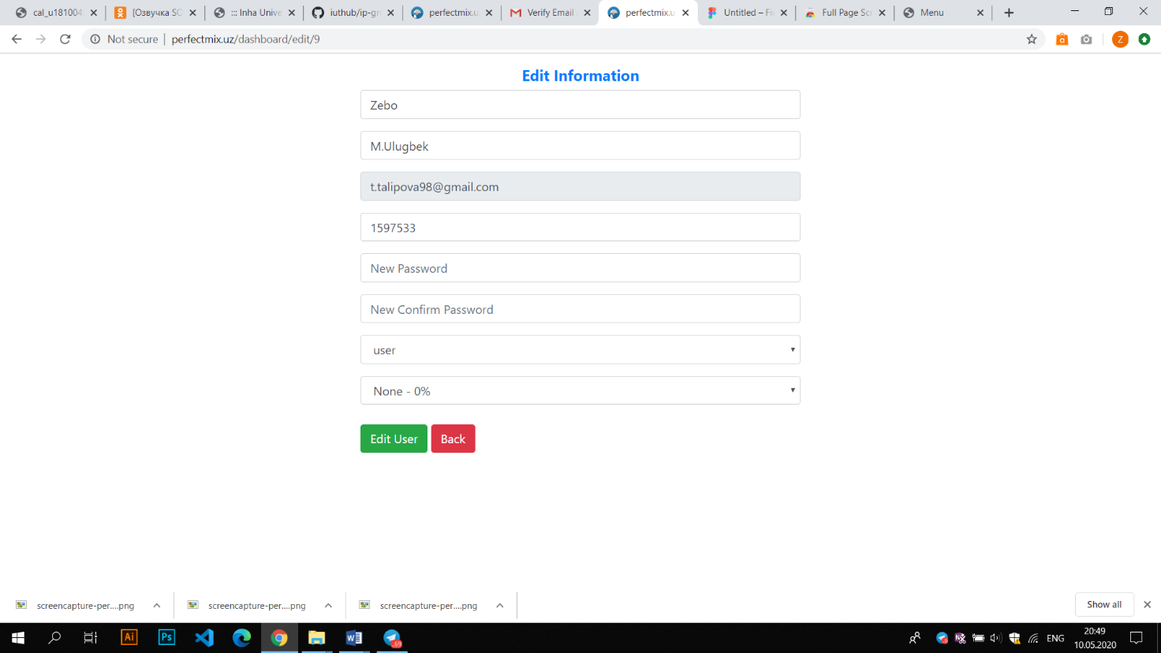

*Pressing edit button provides this page for admin, then admin can reenter the information or can change status of user. Moreover, there are discount input place where admin can percentage of discount to user as premium, silver and bronze.*

Food panel*, this page allows to admin to add new menu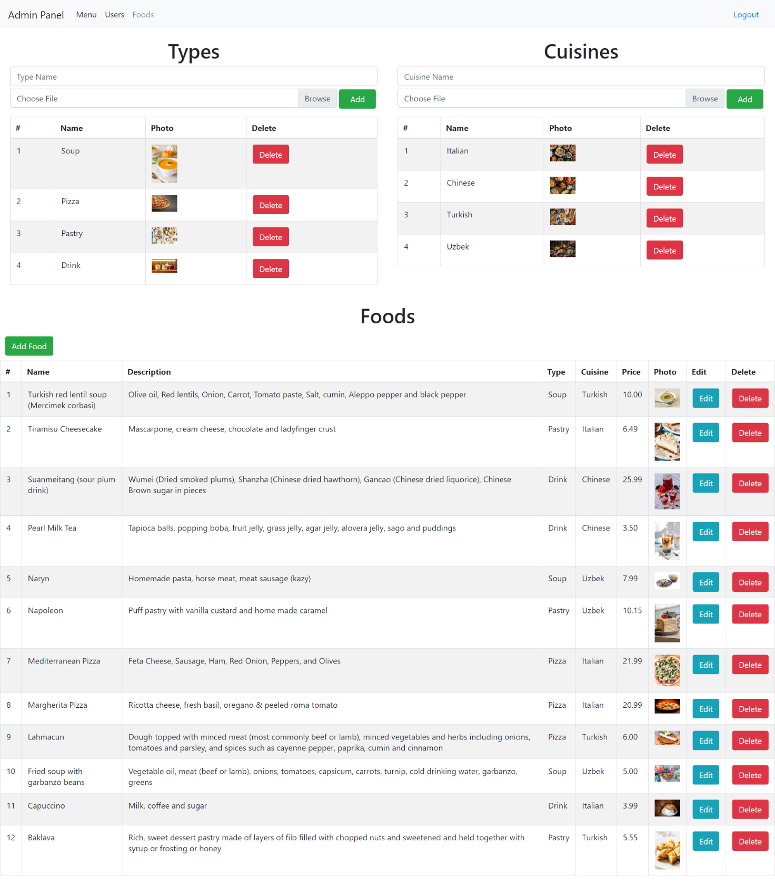*

**Input Validation**

We used both client-side and server-side validation to prevent some problems.

Using client-side validation makes process fast and will not overload the server with mistaken requests. If user enters wrong information or in wrong format they will get error notification from server-side, then users will be frustrated, because they will need to enter information again and again, till they finish with correct info. These attempts will be hard to users firstly, because the user loses his time, after frustrating, they even leave our website, it means there will be -1 client for our company and this will tend to loose income too. Not using client-side validation makes the server too busy, too many users request from server, so the server will be busy with handling lots of data validation as well as more important tasks. Being busy with lots of tasks will decrease the response time to user, which is also disadvantage for user and company as well.

If there will be vice-versa (using client-side validation only), make the web service unsafe! Some advanced users may request to server by passing through validation by using other programs like curl or postman rather than browsers. Getting wrong data in wrong format will cause errors in Database which can stop whole application too.

To prevent these kinds of situation we used combination of client and server side validation.

If user enters wrong info, they cannot send request to server, they get message immediately from browser:

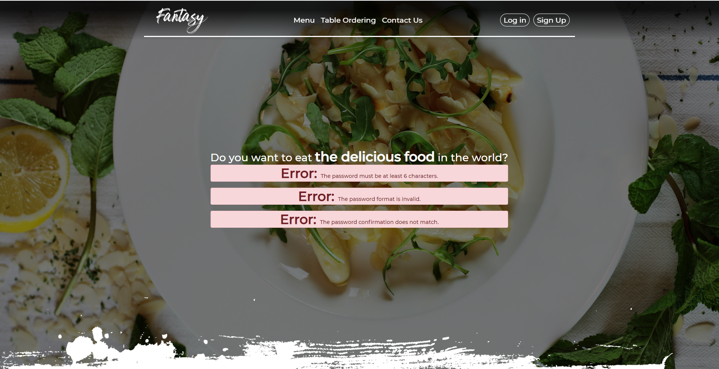

These error shown when user wanted to register but entered credentials in wrong format

The same validation is written from server-side too:

As Validation tool we used RegEx:

|  |  |  |
| --- | --- | --- |
| Name | /[A-z]{2,}/ | This will prevent all characters except letters, because real name can include at least two letters. |
| Phone number | /^[0-9\+]{7,}$/ | This will let only + sign and digits. (At least 7) |
| Password | /.{6,}/ | There is only rule for password, it must contain at least 6 any characters |
| Price | /^[0-9]*\.?[0-9]*$/ | When Admin adds products, price should not contain any characters except number end . (for example: 12, 34.56, 0.99, 333.33) |

**Database**

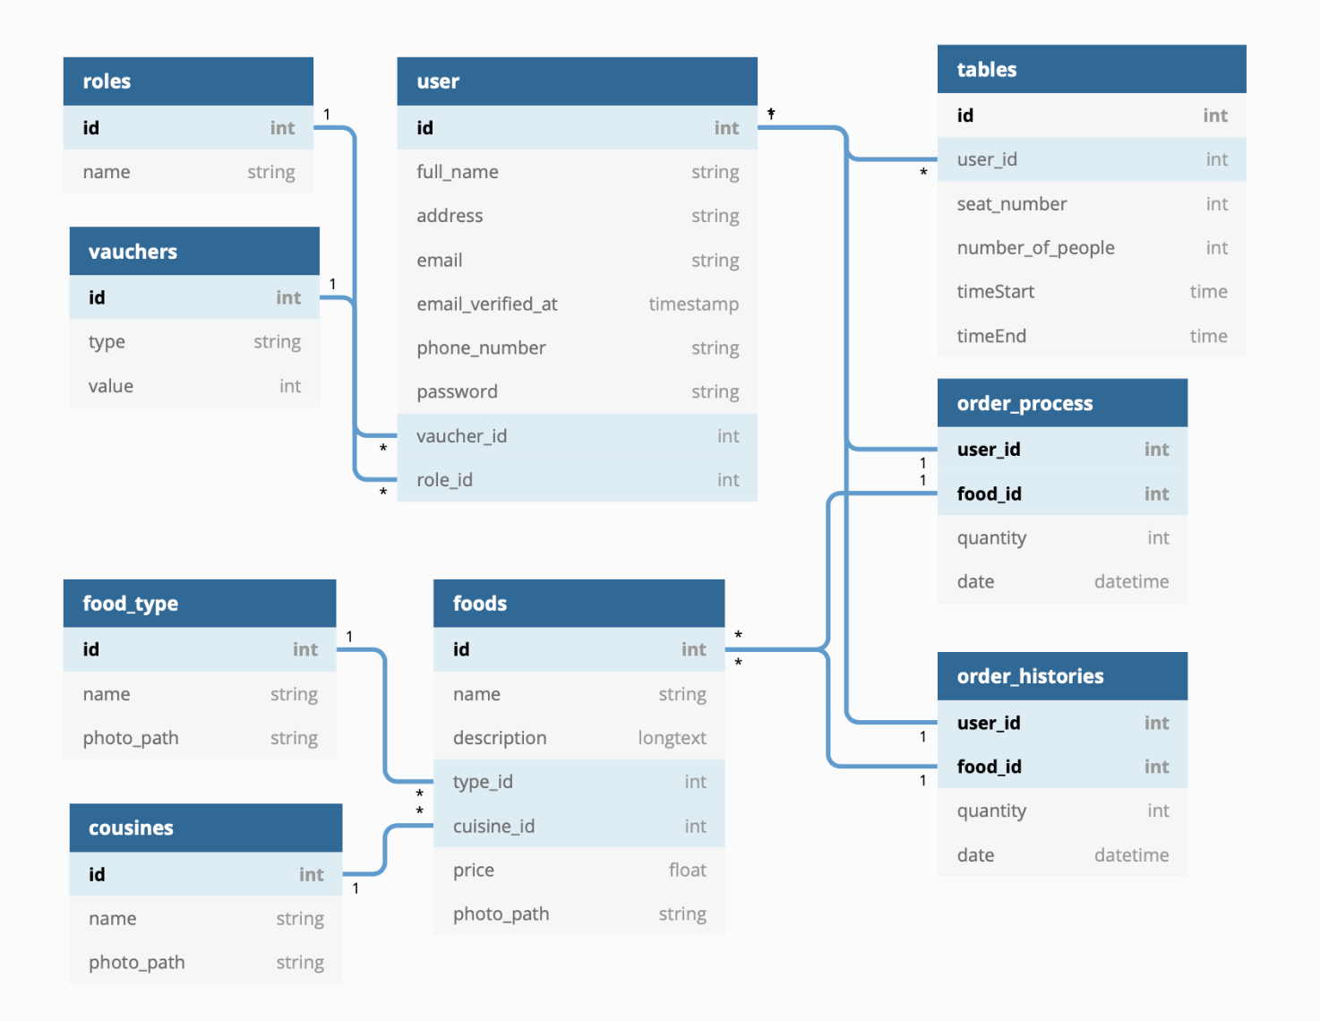

**Migration**

|  |  |  |
| --- | --- | --- |
| One to Many | user | tables |
| roles | user |
| vauchers | user |
| order_process | user |
| foods |
| order_histories | user |
| foods |
| food_type | foods |
| cousines | foods |

We established database for restaurant web application. We have 9 tables to store our data. User and foods table are established for storing users and foods information respectively. “Tables” table for stores the data when user book the table beforehand. Order_process is for when user orders food and order_histories for when administrator accept the food it stores data from order_process. Food_type and cousins tables are created for making food’s type and cuisines dynamic. And we have 9 modules corresponding table and we used Laravel Eloquent Model to communicate our database.

**Server-side Framework Laravel**

At this point every button in navbar has its own special functionality according to its name. But it should be mentioned that navbar changes according to the role of user.

1. **Guest – Person who has not authorized**



1. **Fantasy** – navbar brand button redirects to the main page. When this button is pressed it goes to the mainIndex route with get response and from there it finds appropriate function in PostsContreller which is named getIndex.

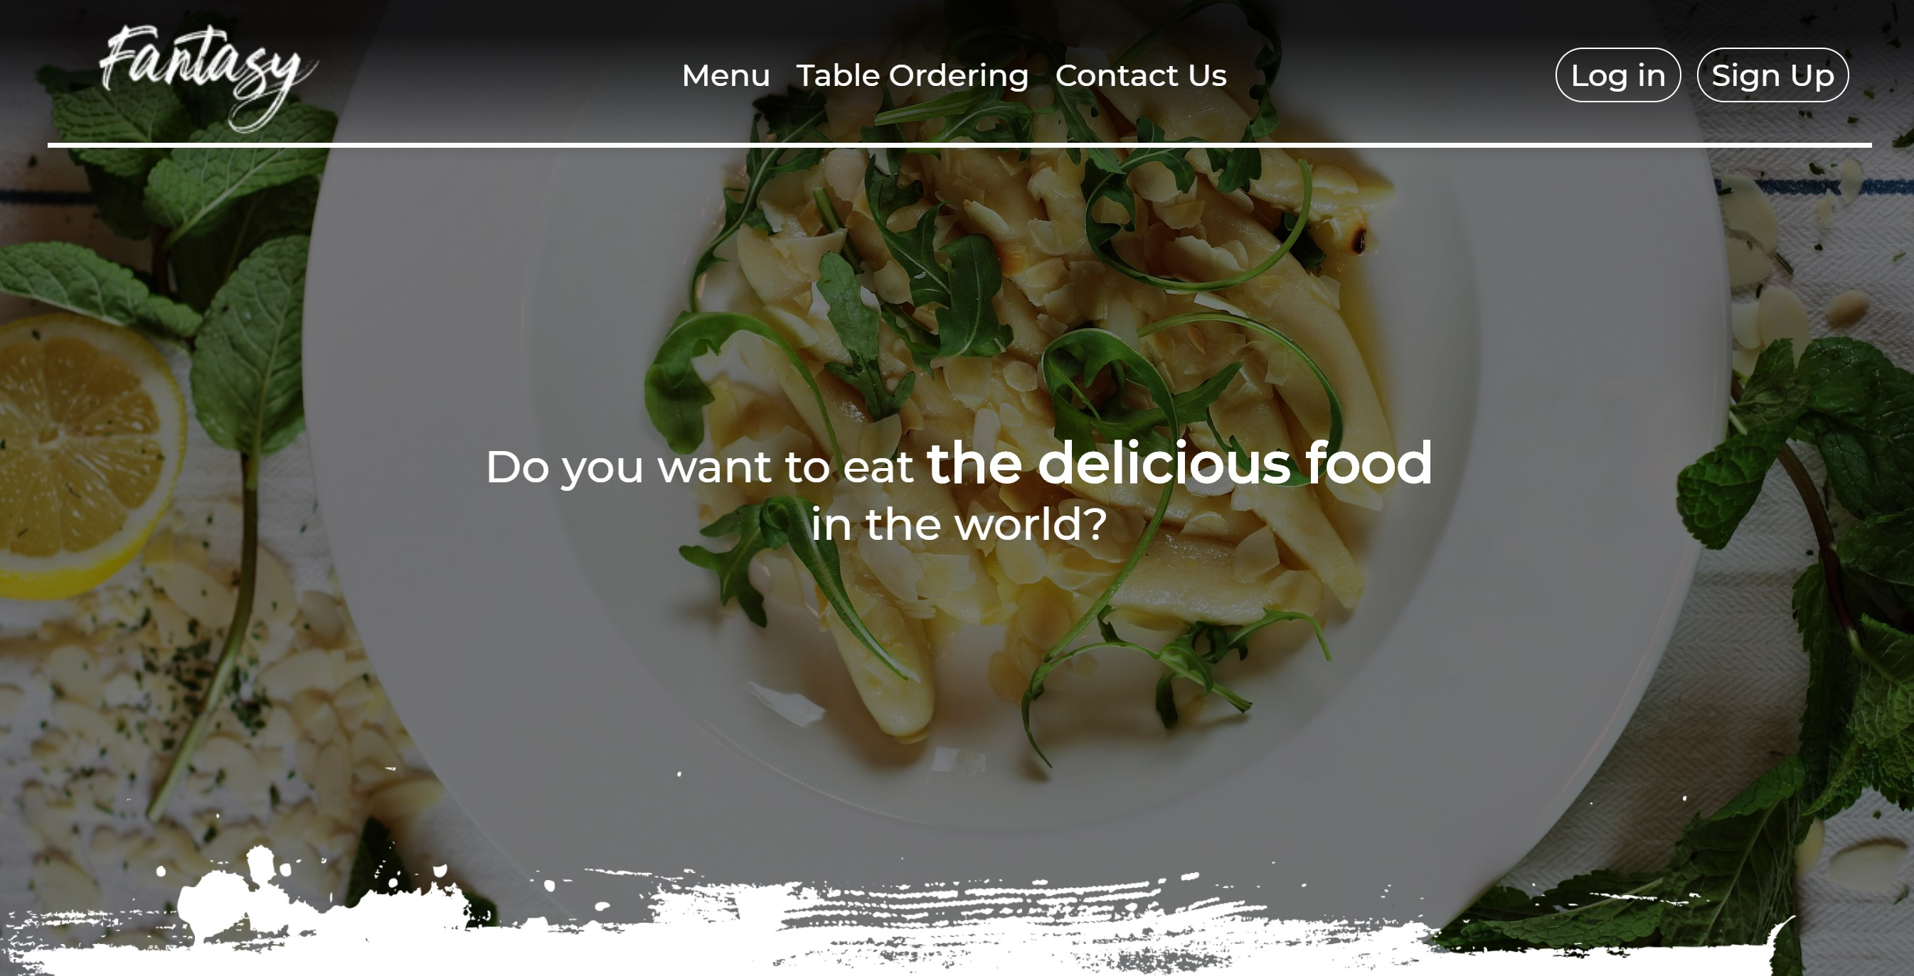

1. **Menu** – this button redirects to the menu page. When this button is pressed it goes to the menuIndex route with get response and from there it finds appropriate function in FoodsController which is named getMenuIndex and shows menu.blade.php.

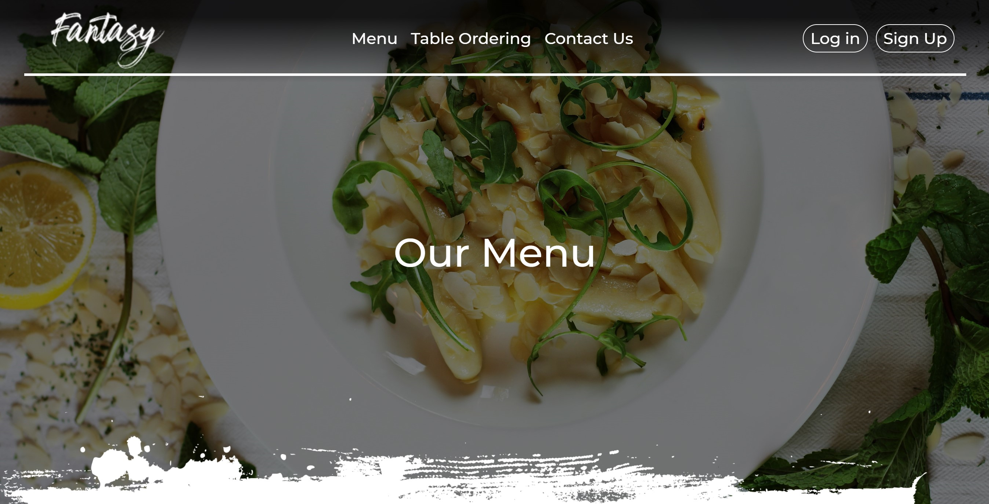

When guest tries to press order button it redirects him/her to login route, because Auth::check() tells that this user not authorized.

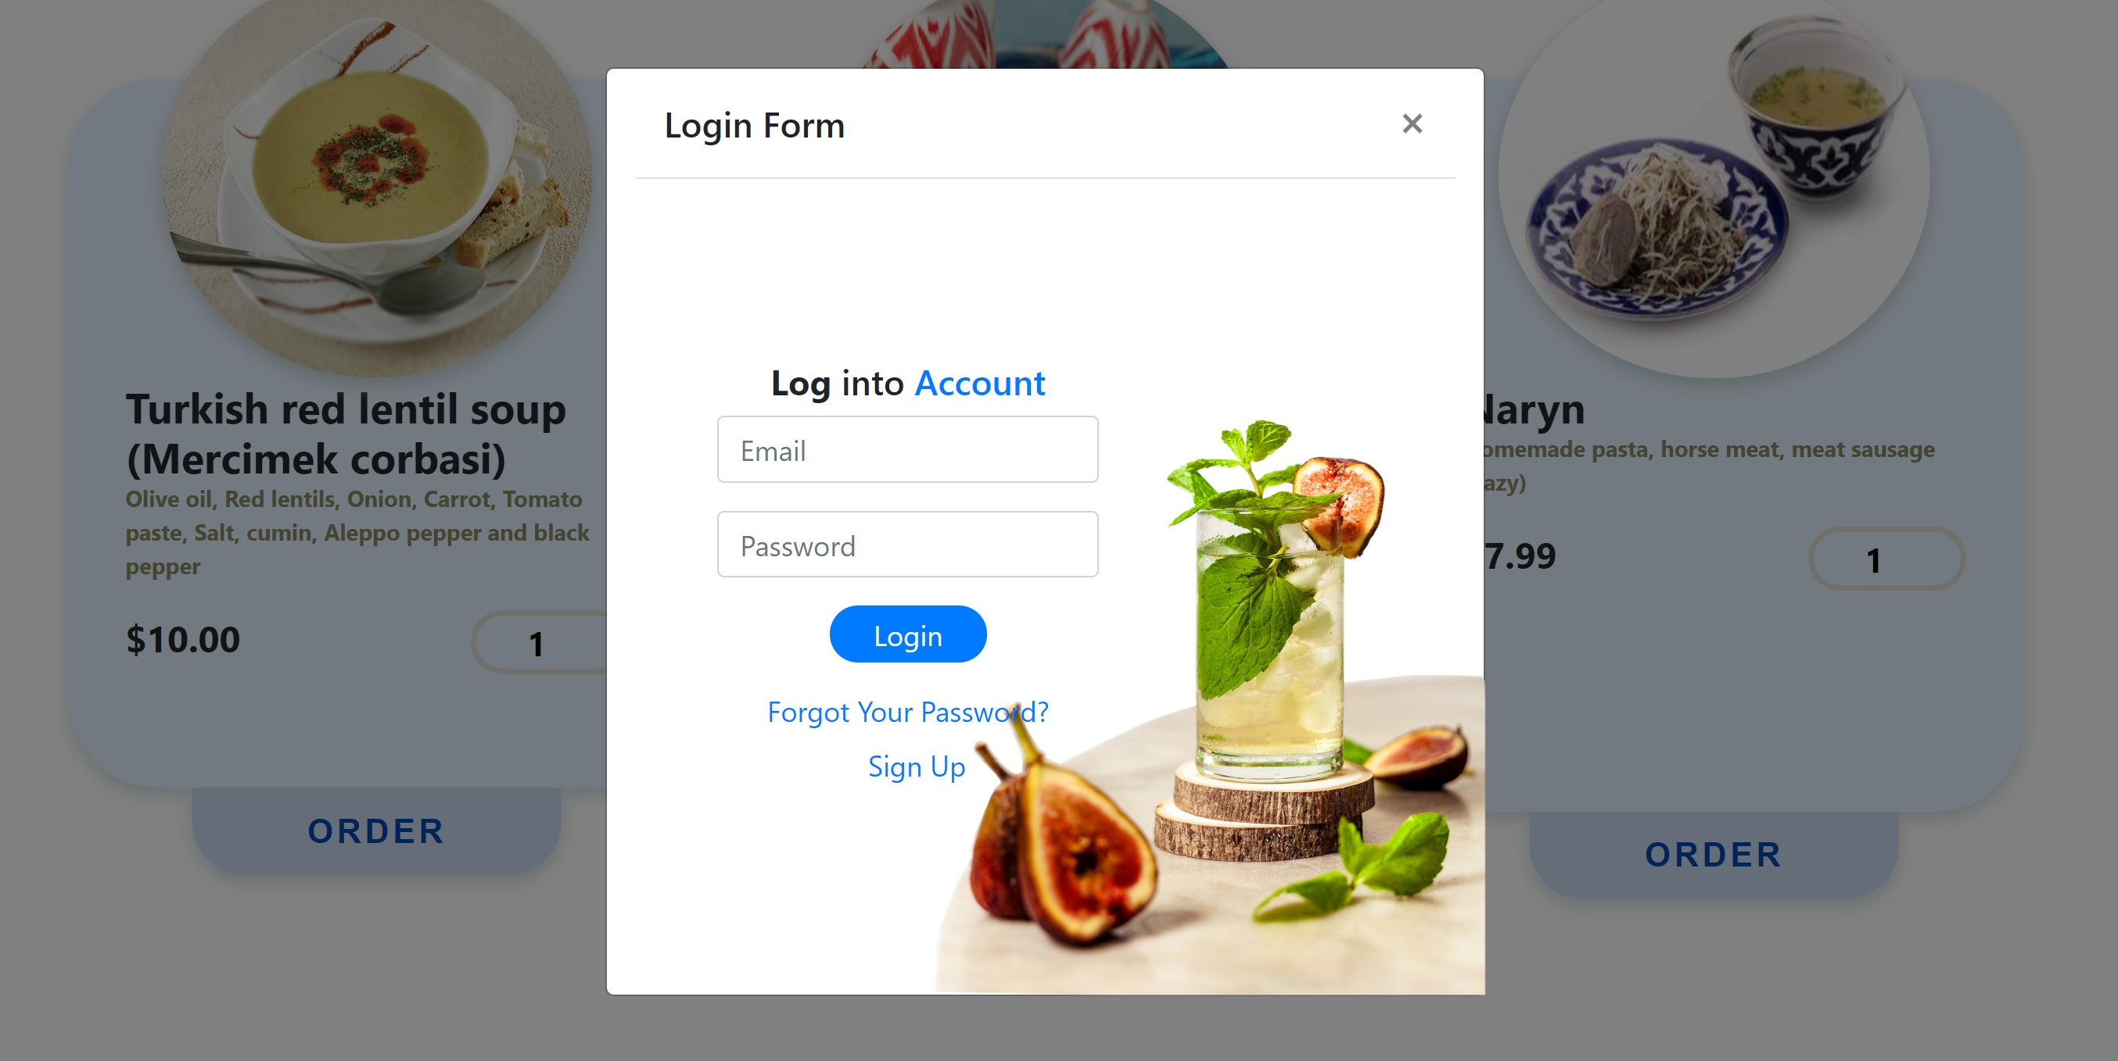

1. **Table Ordering** – this button shows the pop-up menu of table ordering to the guest. When it pressed it cannot go to reserveTable route with post response and do its’ main functionality (going to the table route with post response), because submit button disabled, such that this guest is not authorized.

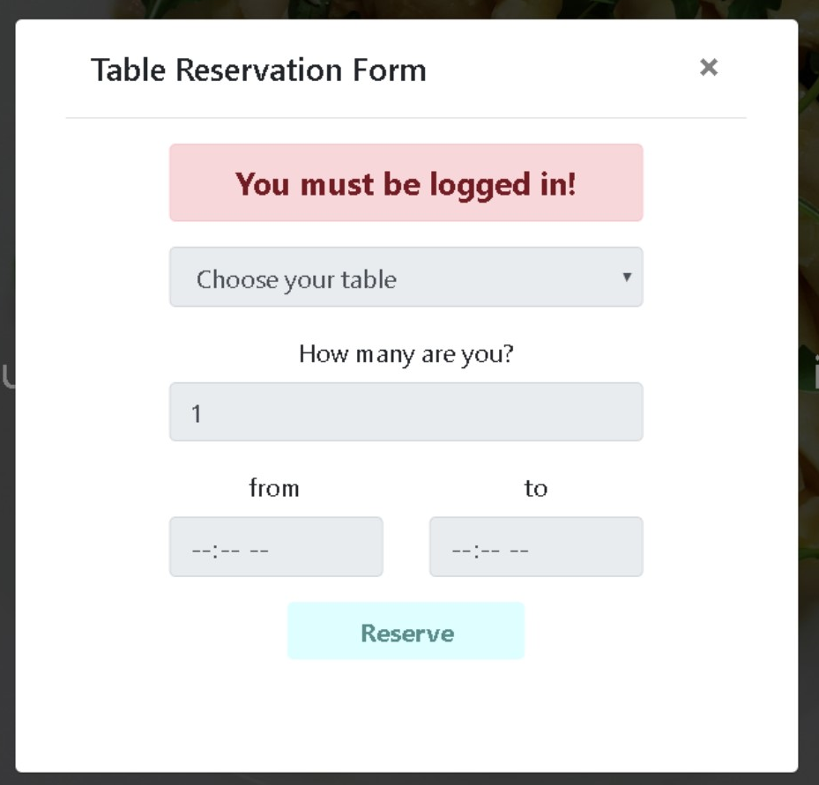

1. **Contact Us** – this button shows the pop-up menu of the feedback part to the guest. When it pressed it cannot go to sendEmail route with post response and do its’ main functionality (going to the sendEmail route with post response), because submit button disabled, such that this guest is not authorized.

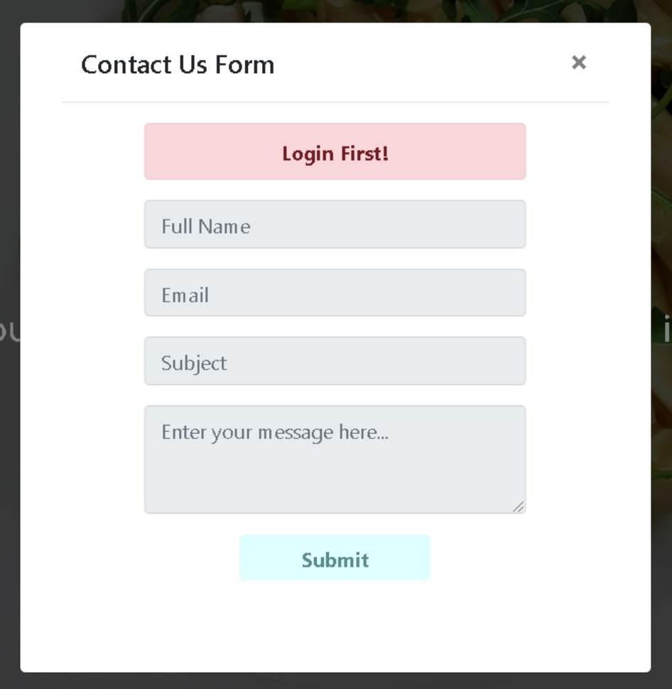

1. **Log in** – this button shows the pop-up menu of the log in to the guest. When this button is pressed it goes to the form in login.blade.php and requires filling the username and password text fields.

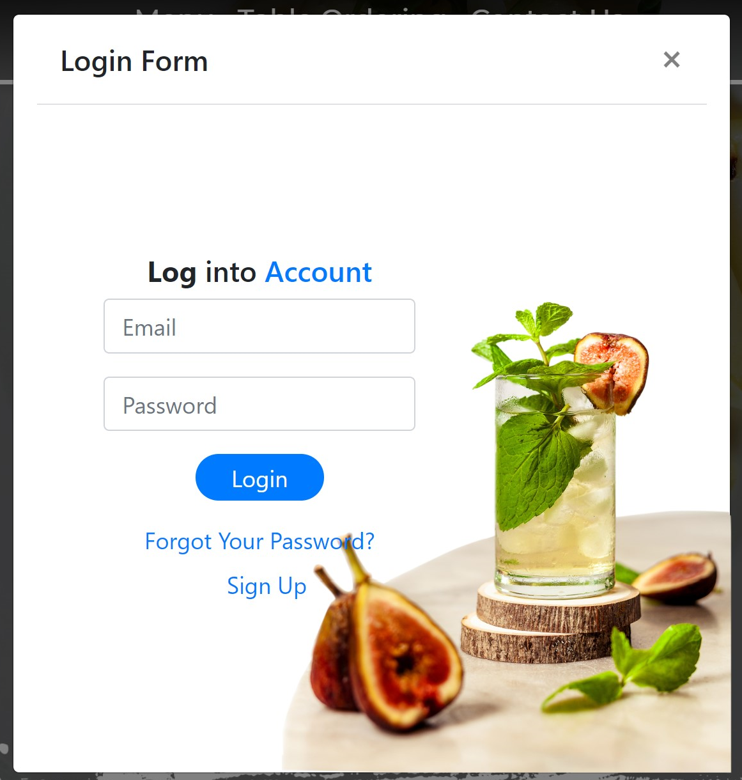

But, this button is not useful for guests, such that they haven’t created any account in this site. Anyways, if they try to fill this form and press login button, it cannot reach login route properly, because after receiving user’s info it goes to the users table in database and there will be mismatch in user’s info in such that there is no any data about this user in database. Similarly, there is no meaning of pressing “Forgot Your Password?” button, it works but it cannot find proper data about guest from database as well and in both cases the following error message will be shown to the user.

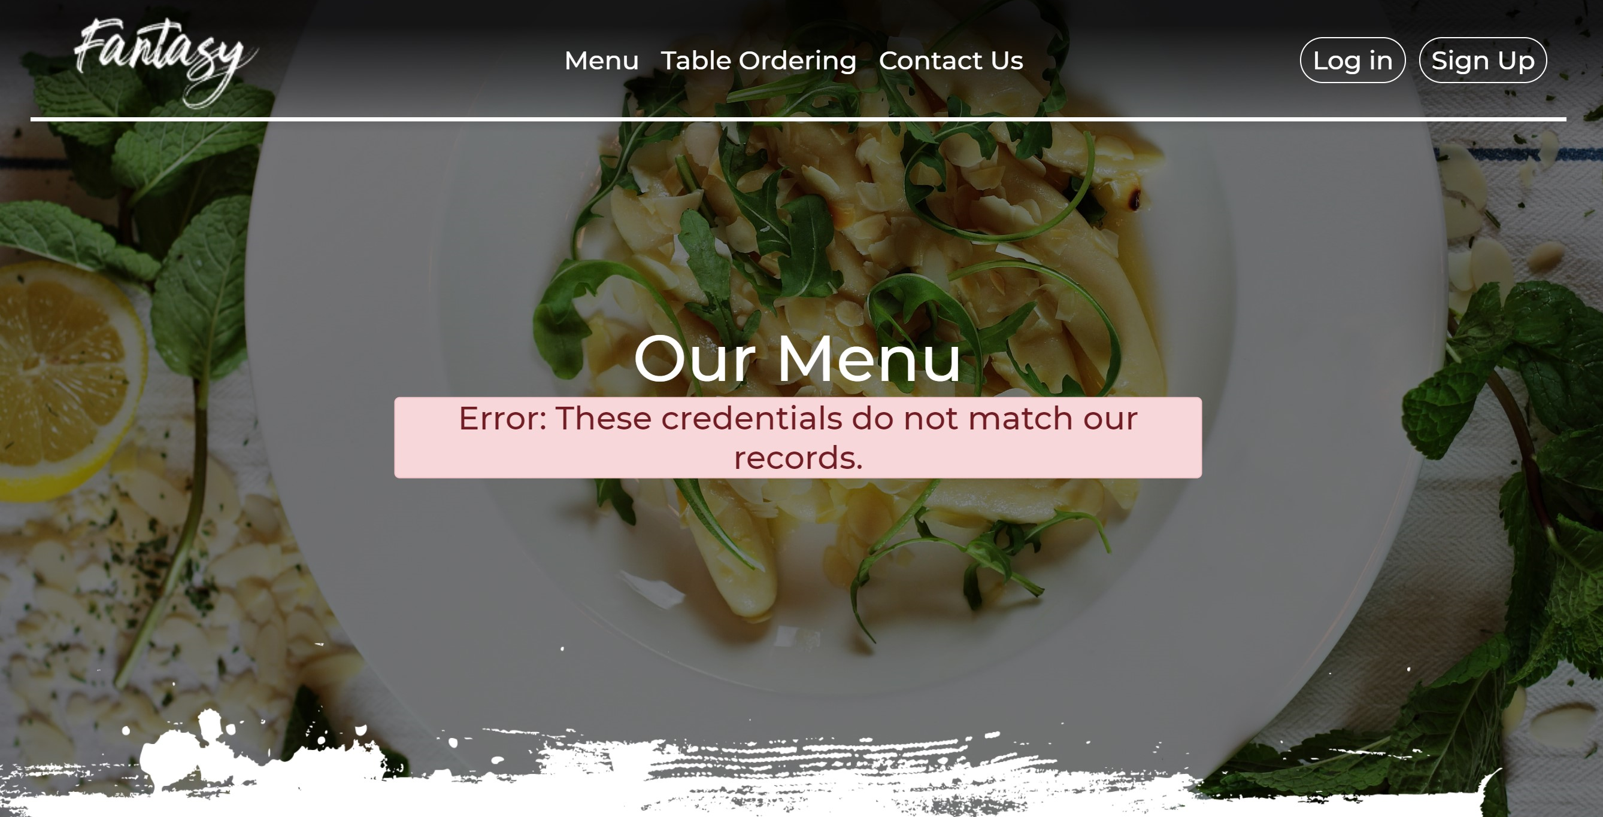

If guests want to register then, they should press “Sign Up” button inside “Login Form” or the last button in site’s navbar.

1. **Sign Up** – this button shows the pop-up menu of the Sign Up to the guest. When this button is pressed it goes to the form in registration.blade.php and requires filling the appropriate fields, like, Full name, Address, Email, Phone Number, Password, Confirm Password.

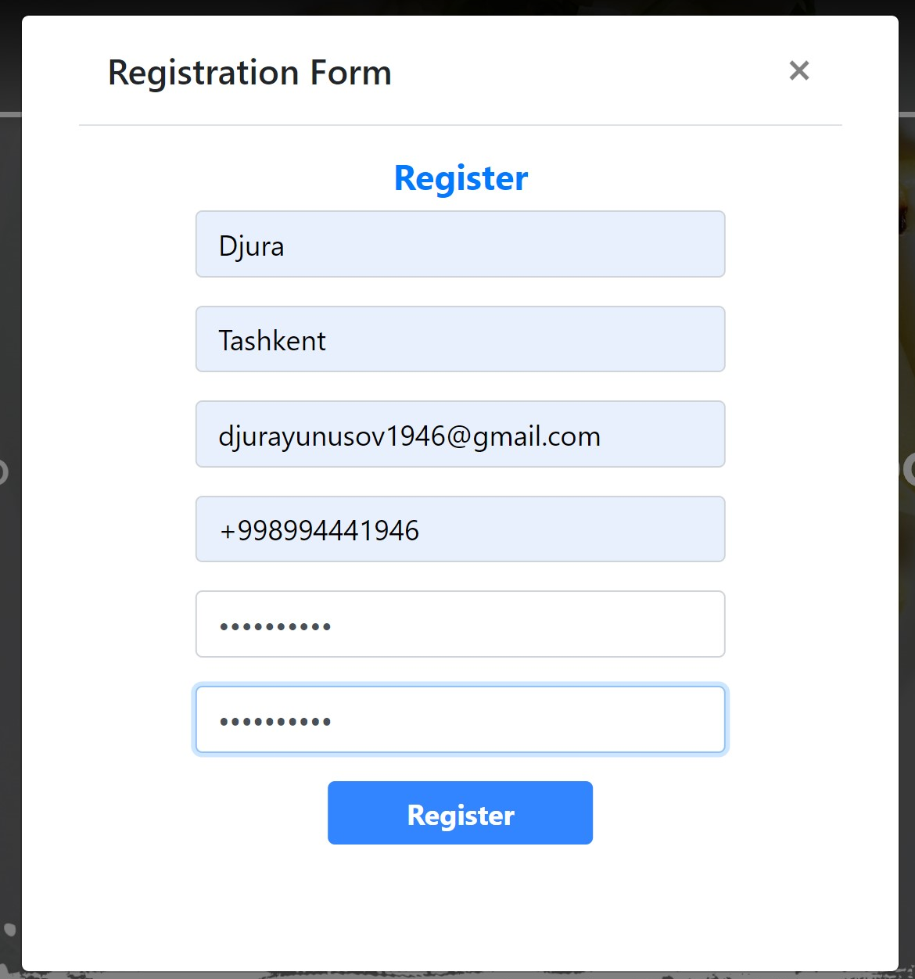

After filling with info, guest should press “Register” button. While clicking this button, form it redirects guest to the verify.blade.php and says that guest should confirm his/her email and after that he/she becomes user.

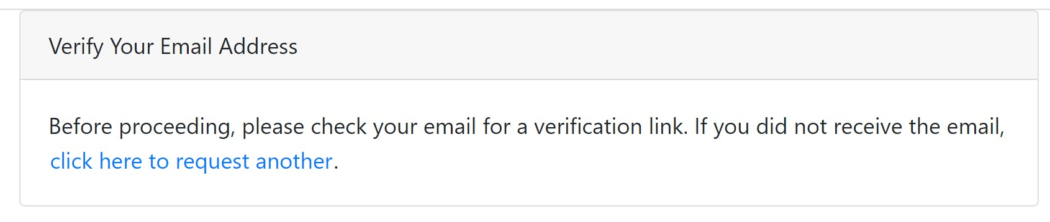

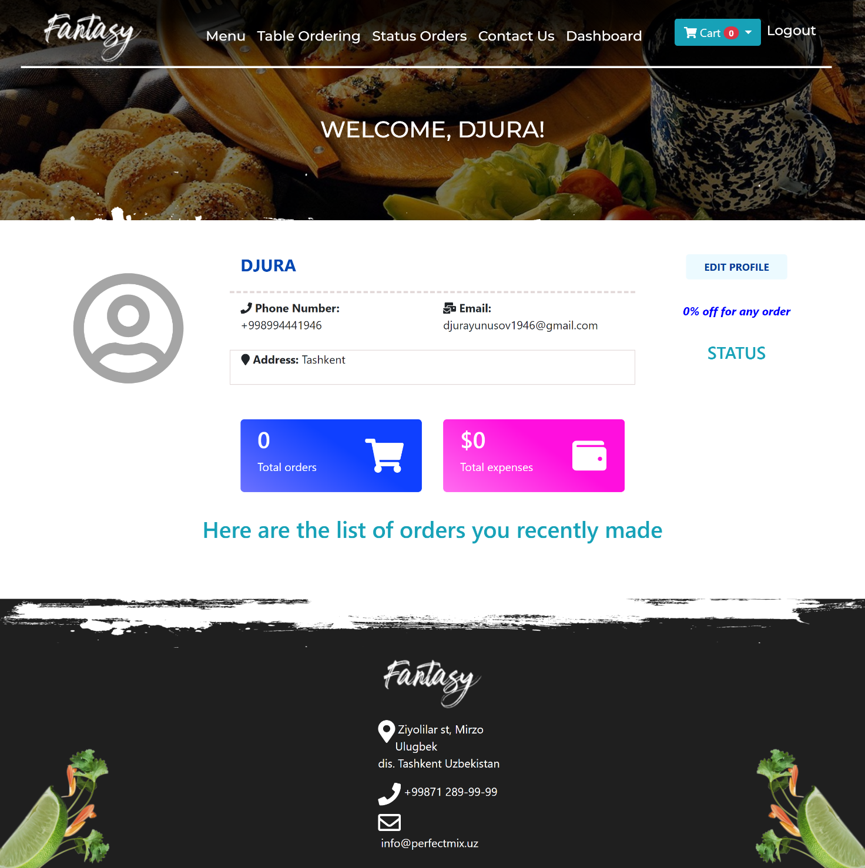

After confirmation, guest becomes User and due to changing of the role his/her main page will be changed.

1. **User – Person who has authorized**



1. **Fantasy** – navbar brand button redirects to the main page. When this button is pressed it goes to the mainIndex route with get response and from there it finds appropriate function in PostsContreller which is named getIndex. But, the difference from ordinary user is in the navaer.blade.php. Inside this blade there were buttons, like “Status Orders”, “Dashboard”, “Cart” and “Logout”, they will work after which user authorized.

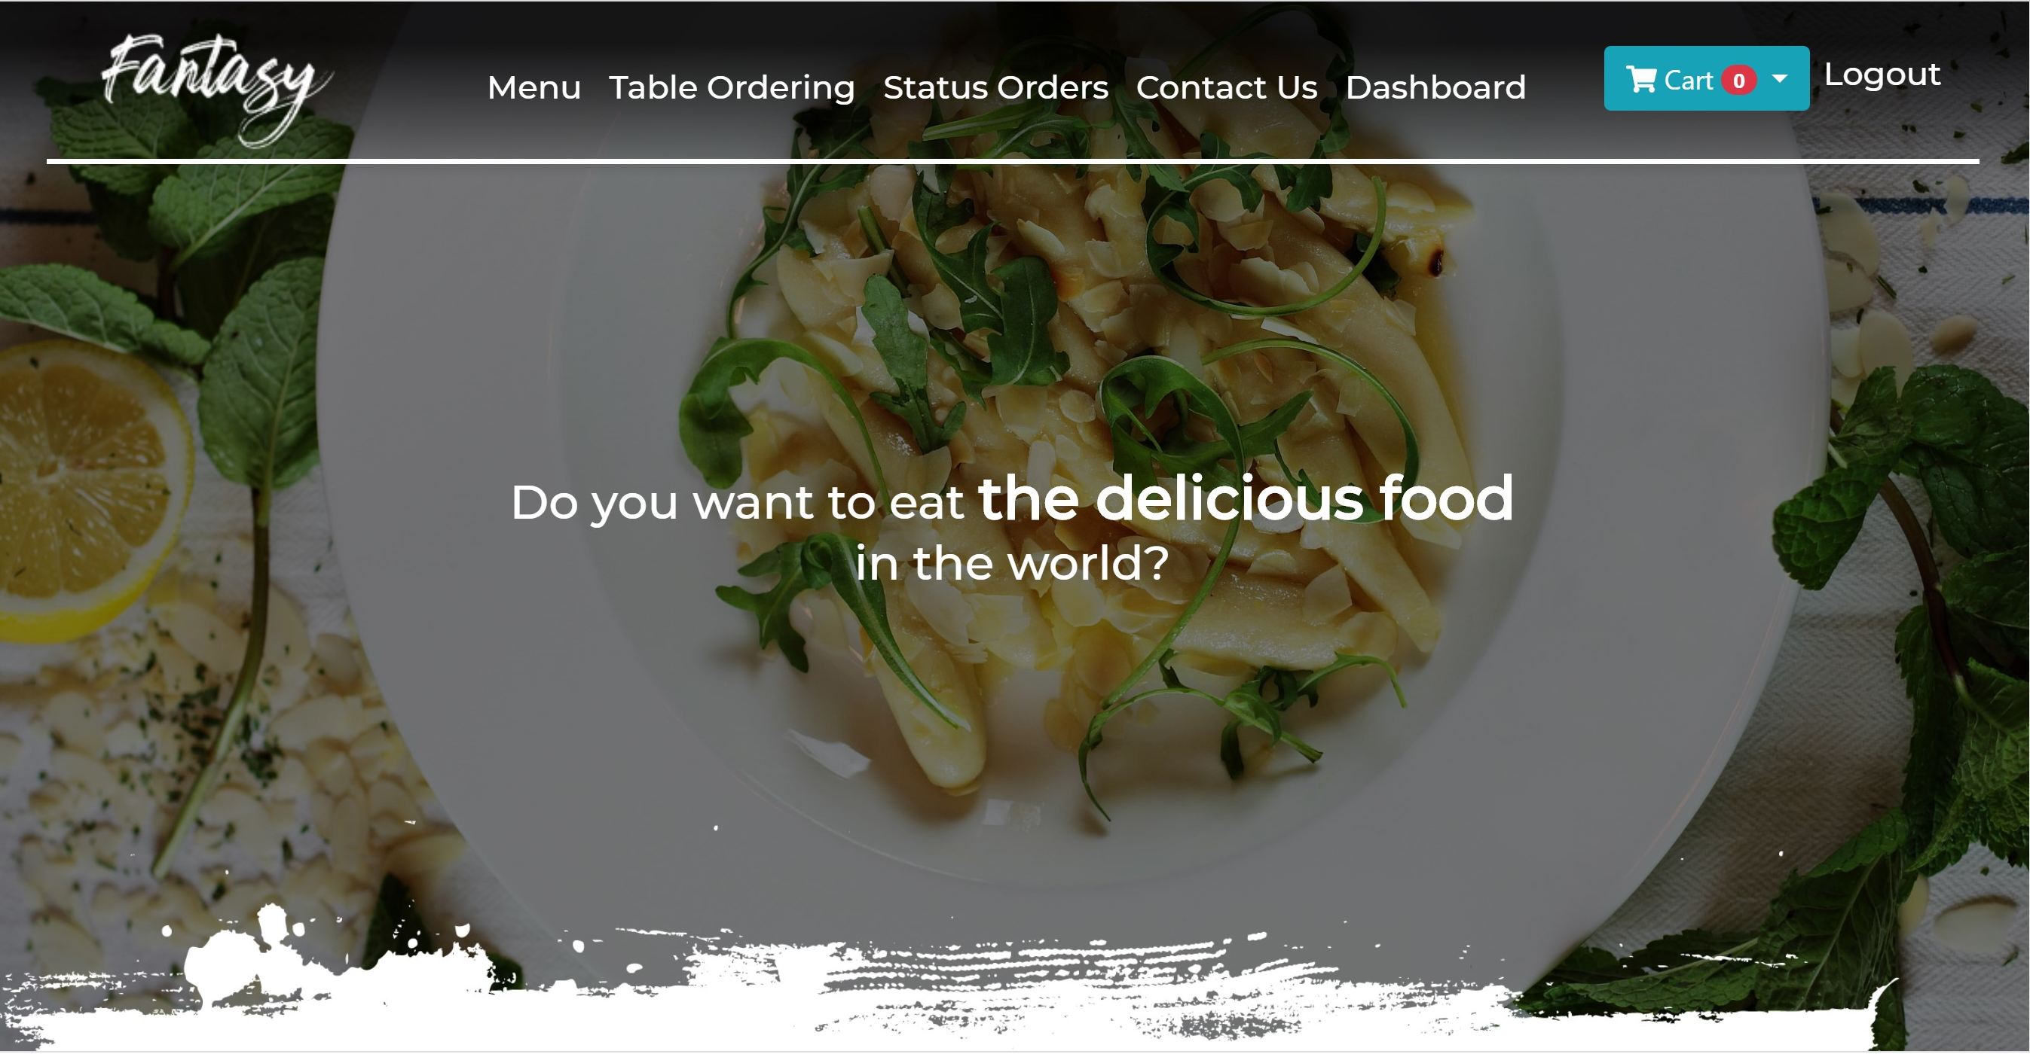

1. **Menu** – this button redirects to the menu page. When this button is pressed it goes to the menuIndex route with get response and from there it finds appropriate function in FoodsController which is named getMenuIndex and shows menu.blade.php.

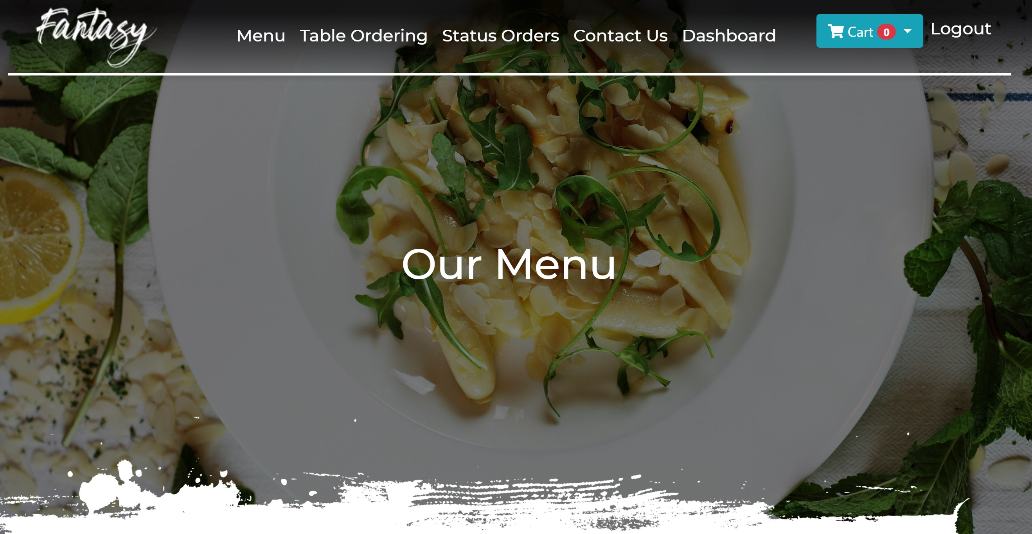

User can choose food type like “Soup” or “Pizza” and when they click these words it scrolls the page to necessary food type collection. For doing this $first_type variable is used to indicate the placement of the collection.

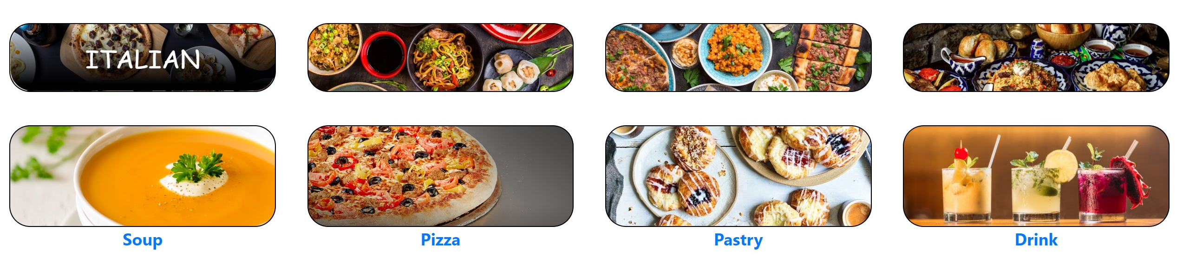

User can choose the quantity of food with following field.

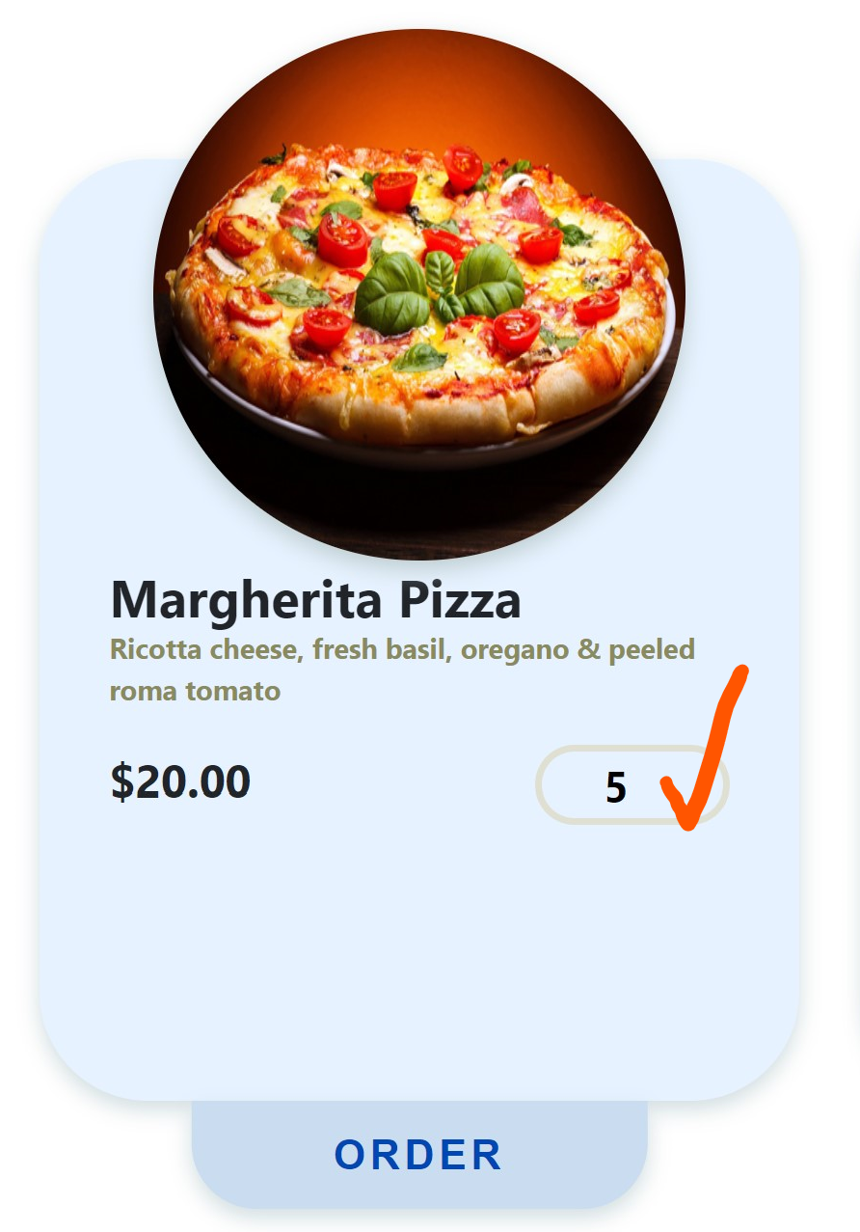

After selecting the quantity if user presses order button, it goes to addToCart route with post method and from there it finds appropriate function addToCart from CardsController and awakes the following alert message.

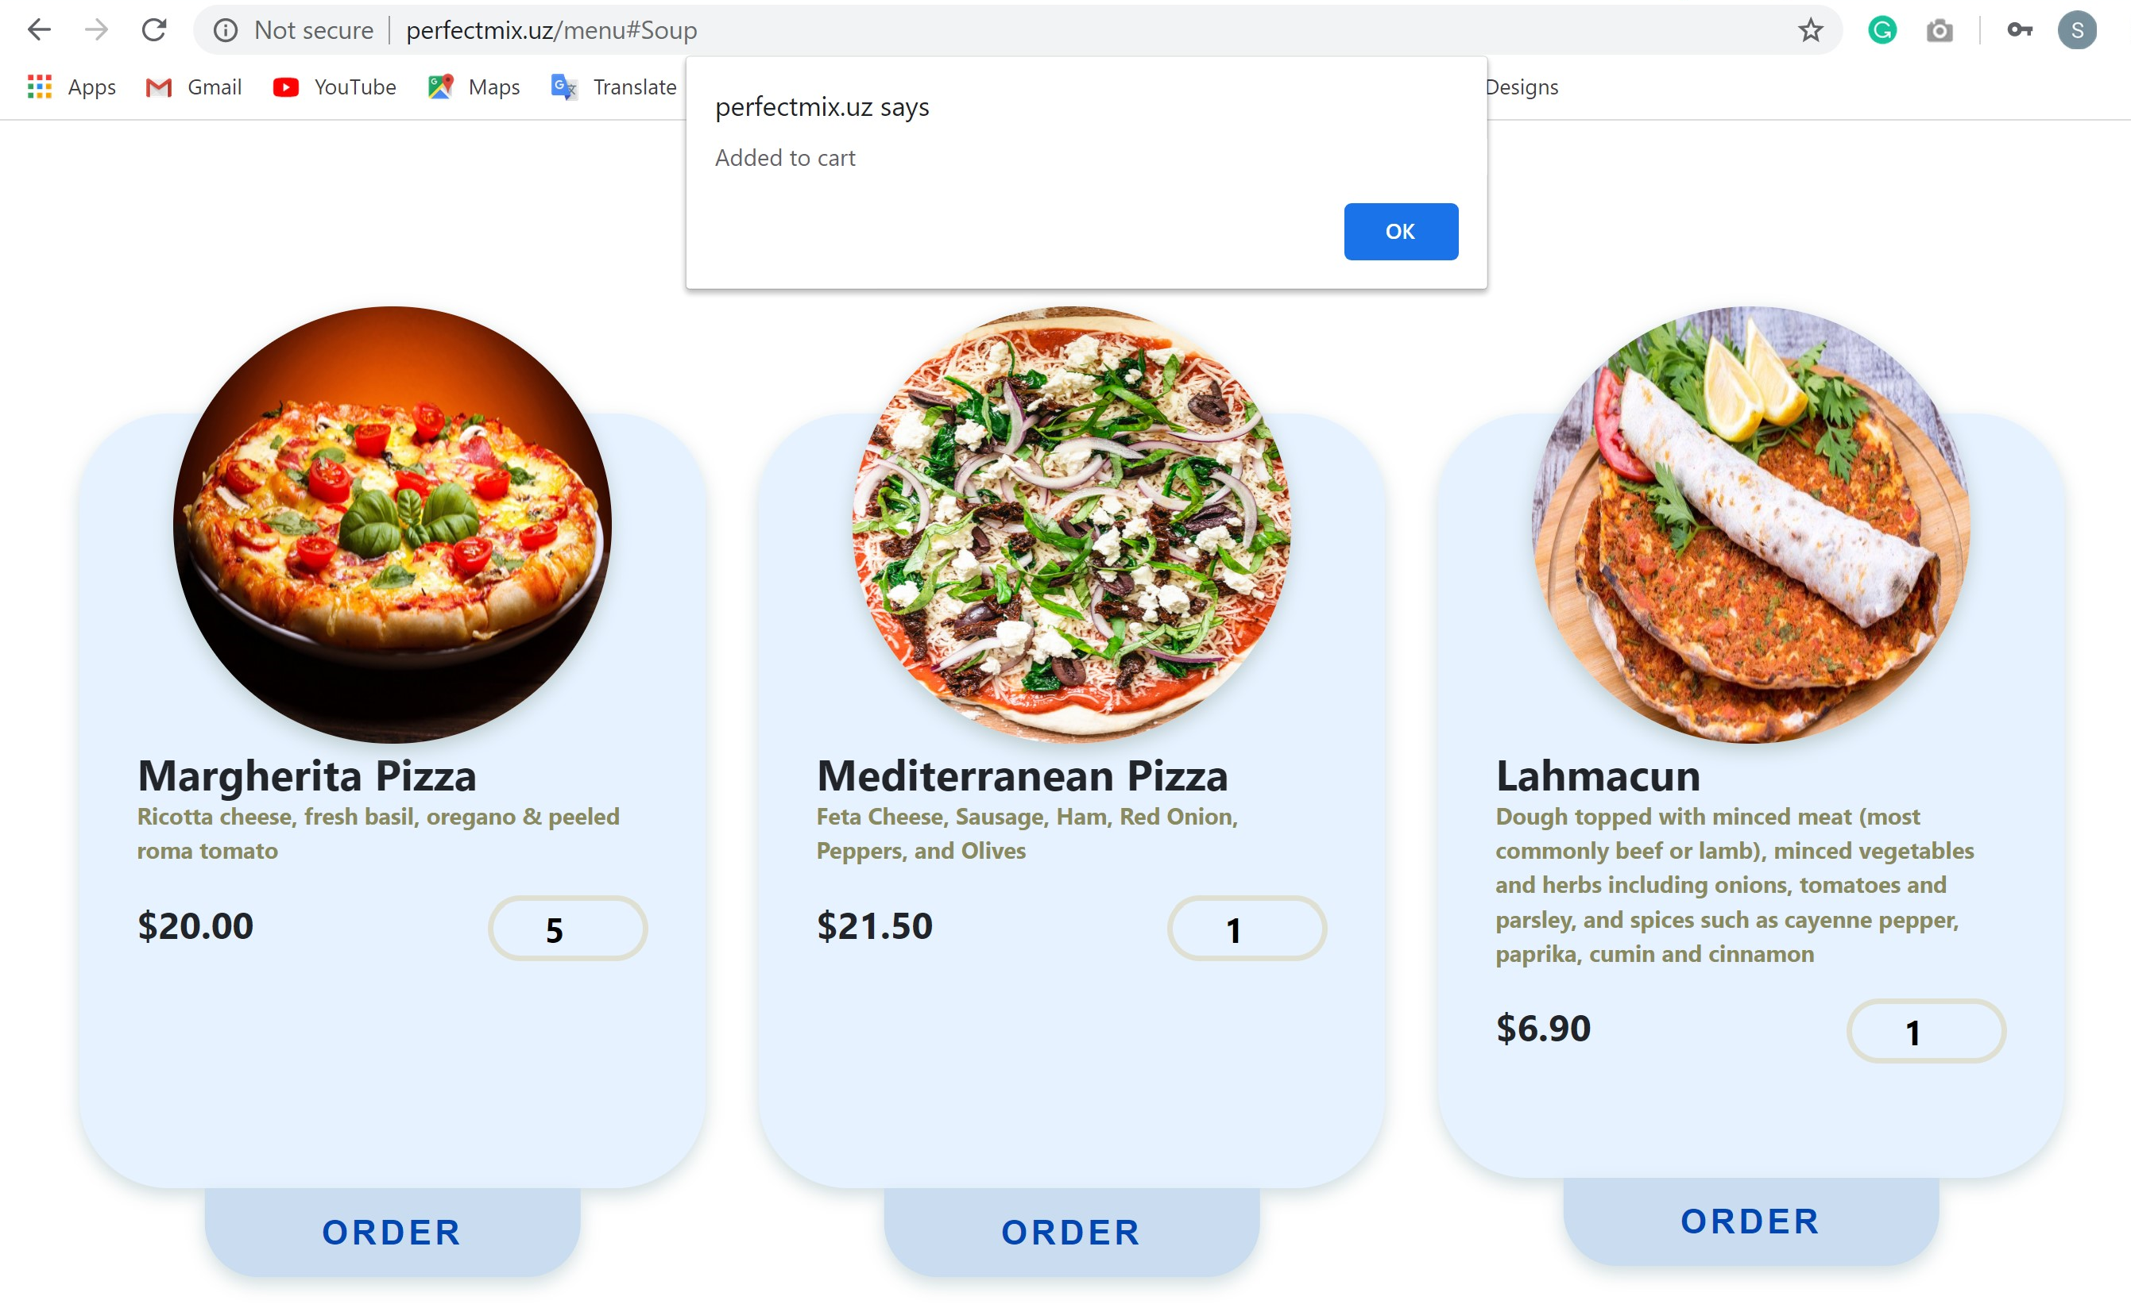

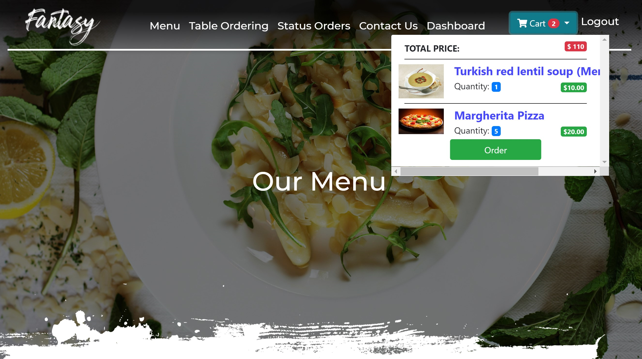

From there we can see that all our selections are saved here inside our basket. In navbar.blade.php there are functions which can calculate the total sum of our selections according to their quantity and send them to CardsController. Next, if “Order” pressed it goes to getCard route with get method and from there it finds appropriate function getCard from CardsController. And this function redirects the user to card.blade.php with following info.

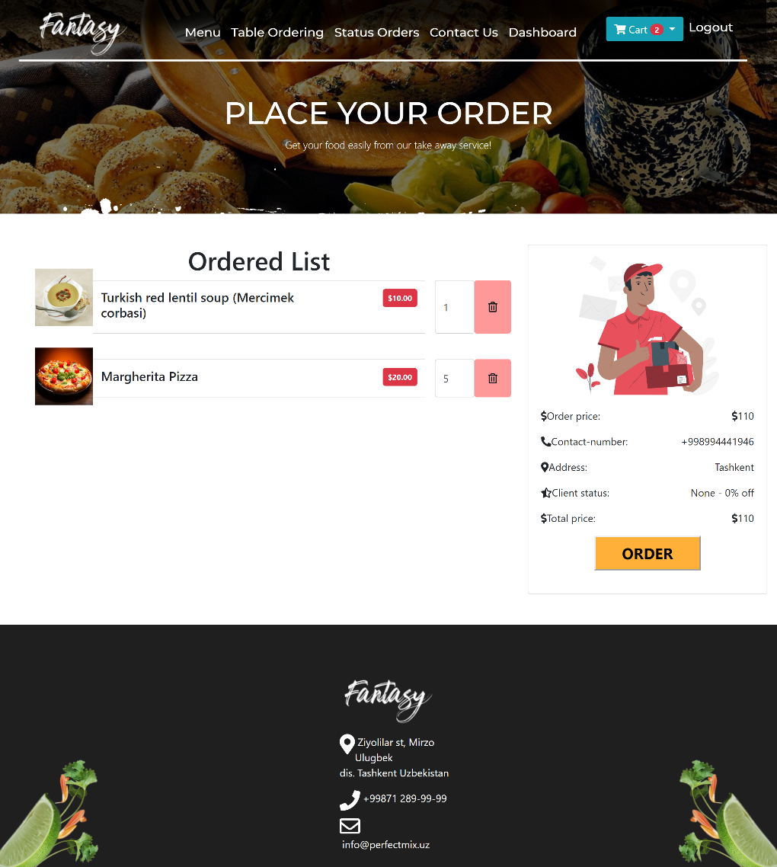

Here user can delete his/her orders and there in or to prevent accidental deleting Ajax is used with alert message “Are you sure?” as shown below.

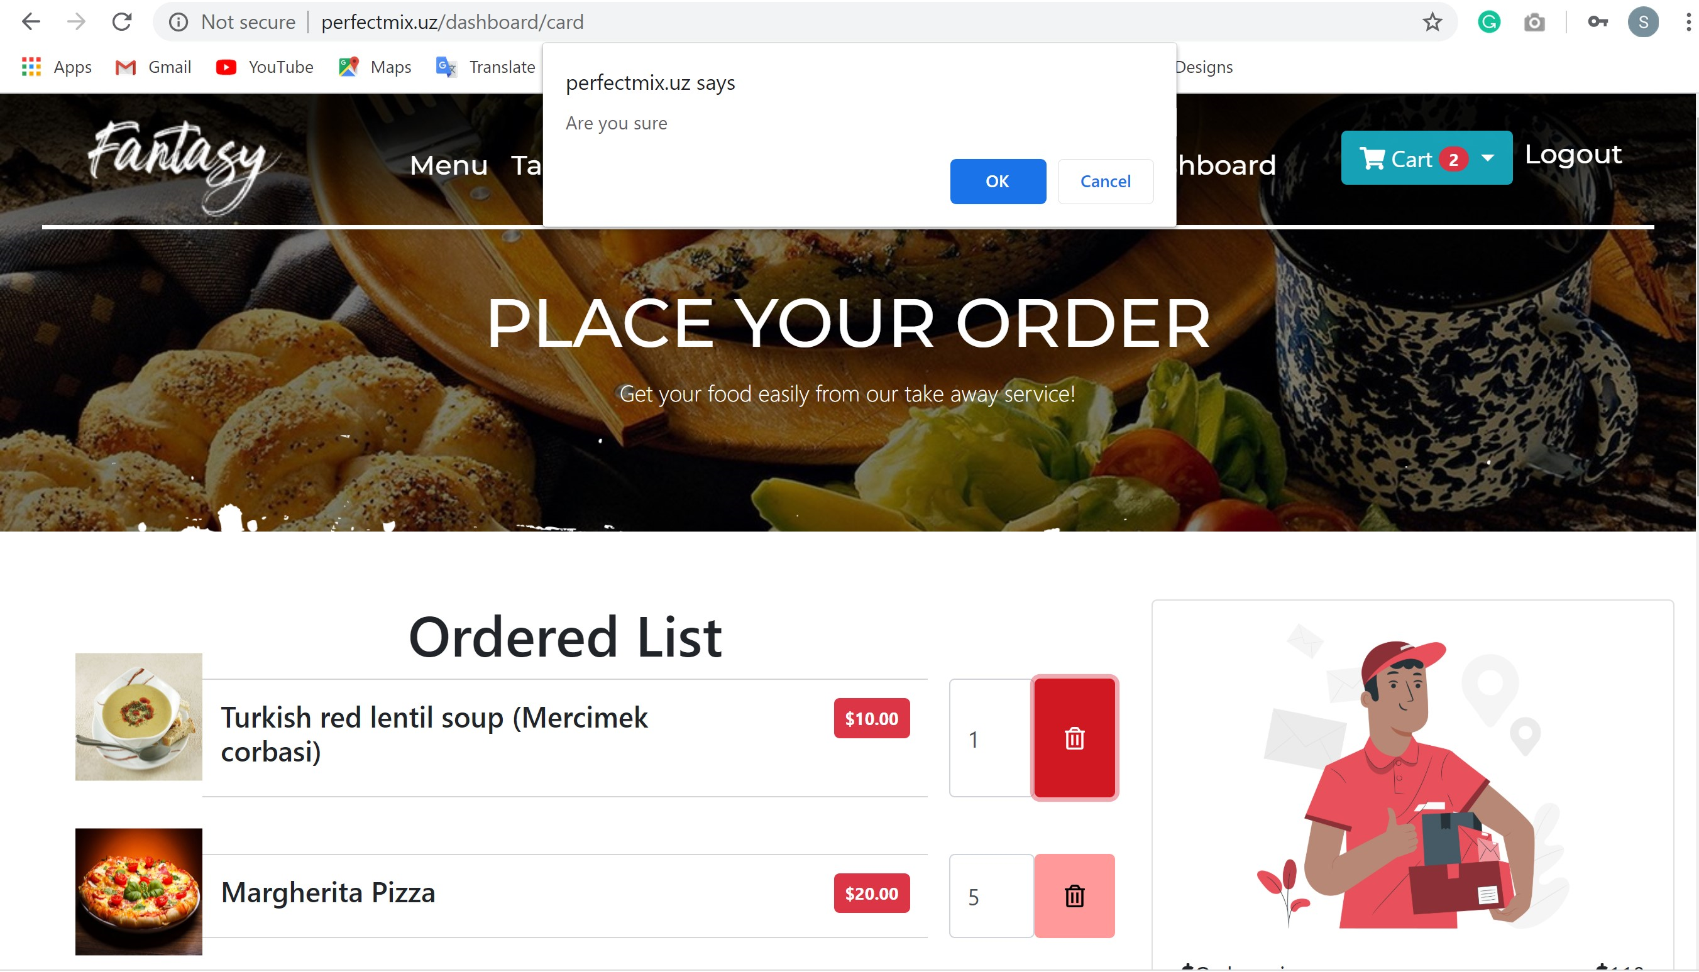

Then after finishing ordering user should press “Order” button and it goes to session “cart” and sends alert message “Successfully updated!” to dashboard.

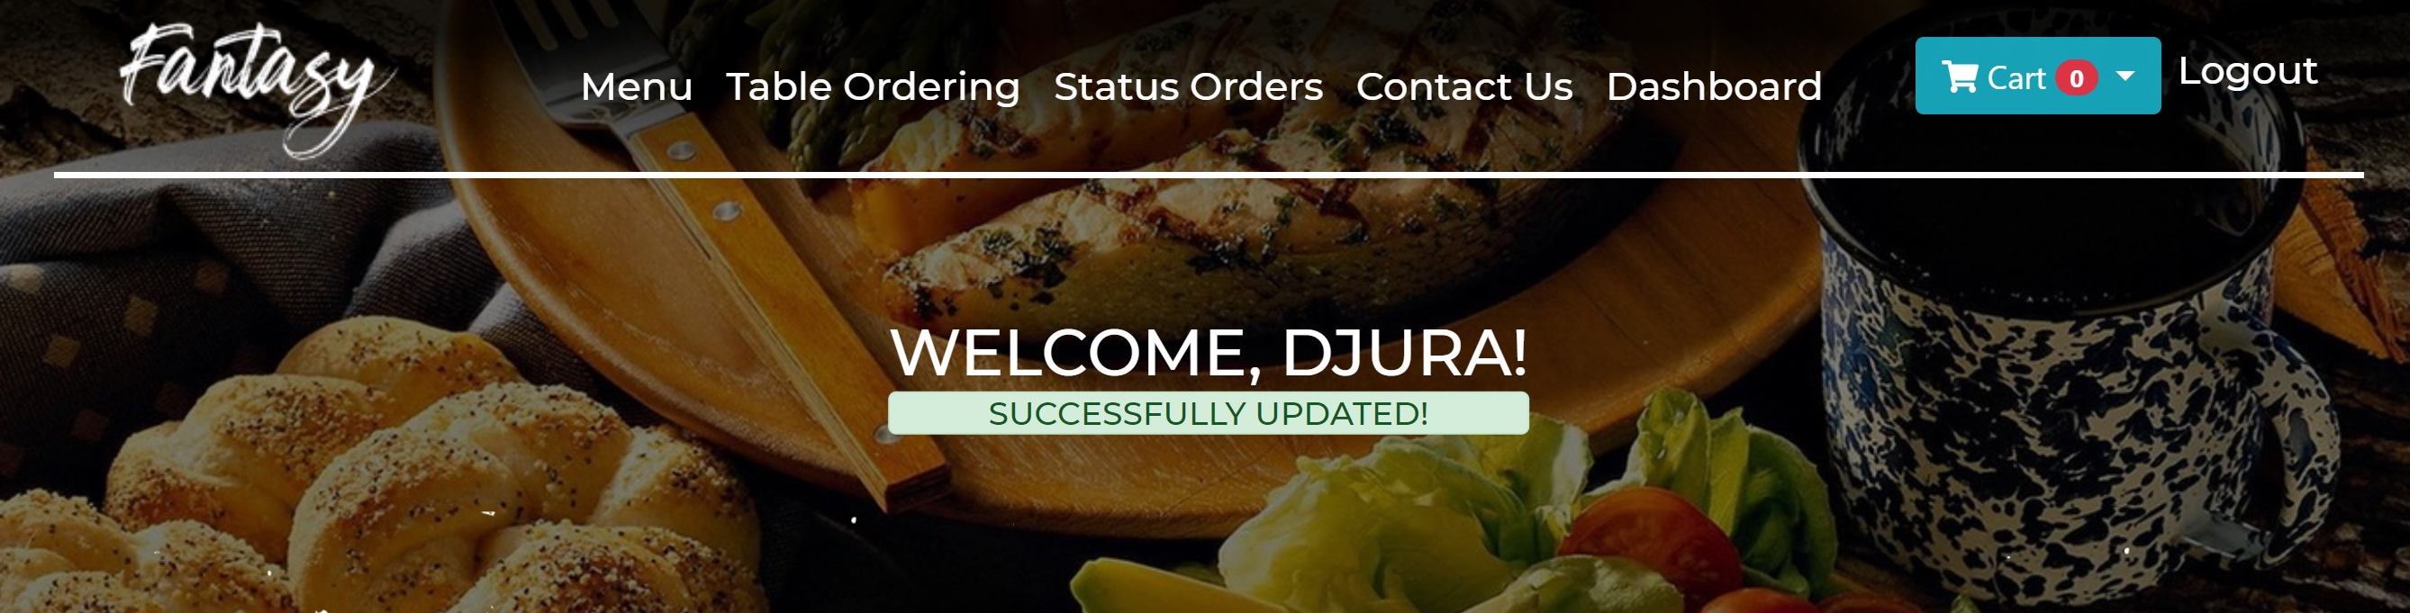

1. **Table Ordering** – this button shows the pop-up menu of table ordering to the guest. When it pressed it goes to reserveTable route with post response and from there it finds appropriate function tables from PostsController.

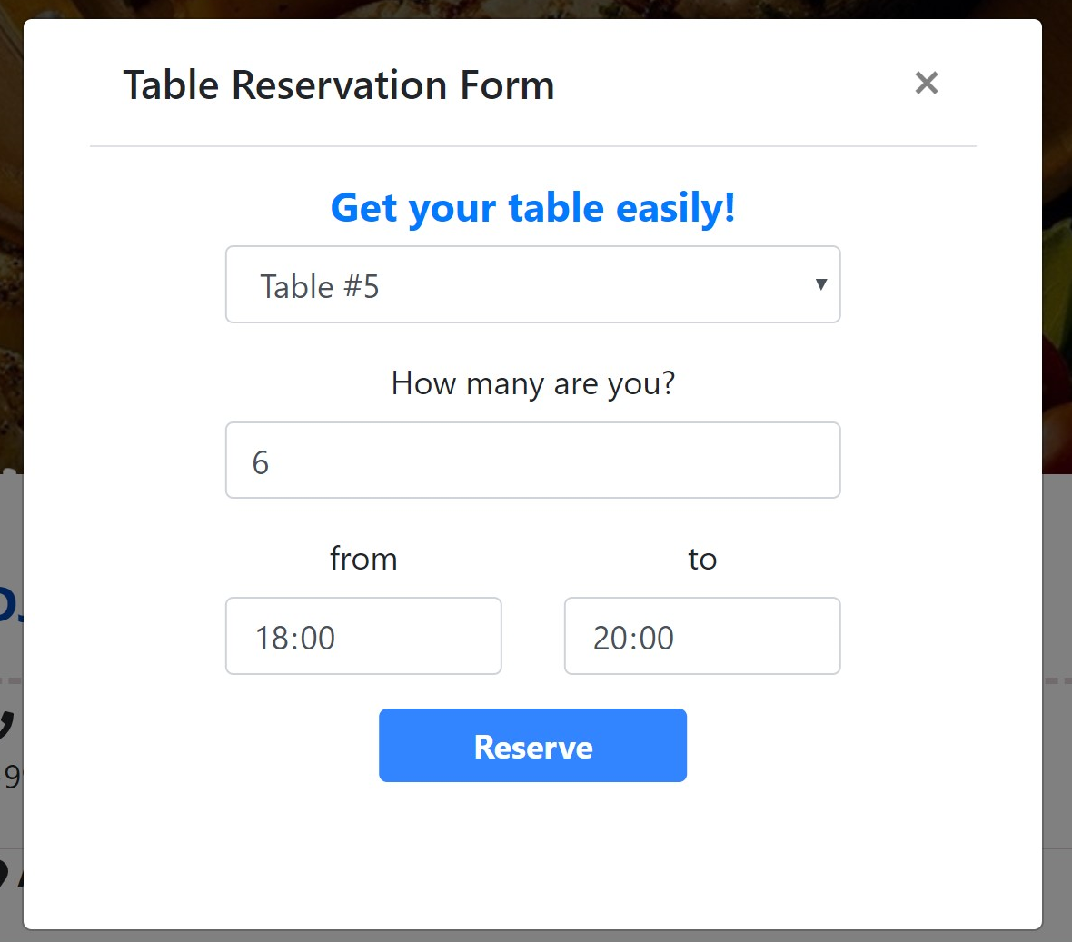

When user presses “Reserve” button it redirects route to dashboardIndex with info “Table booked!”

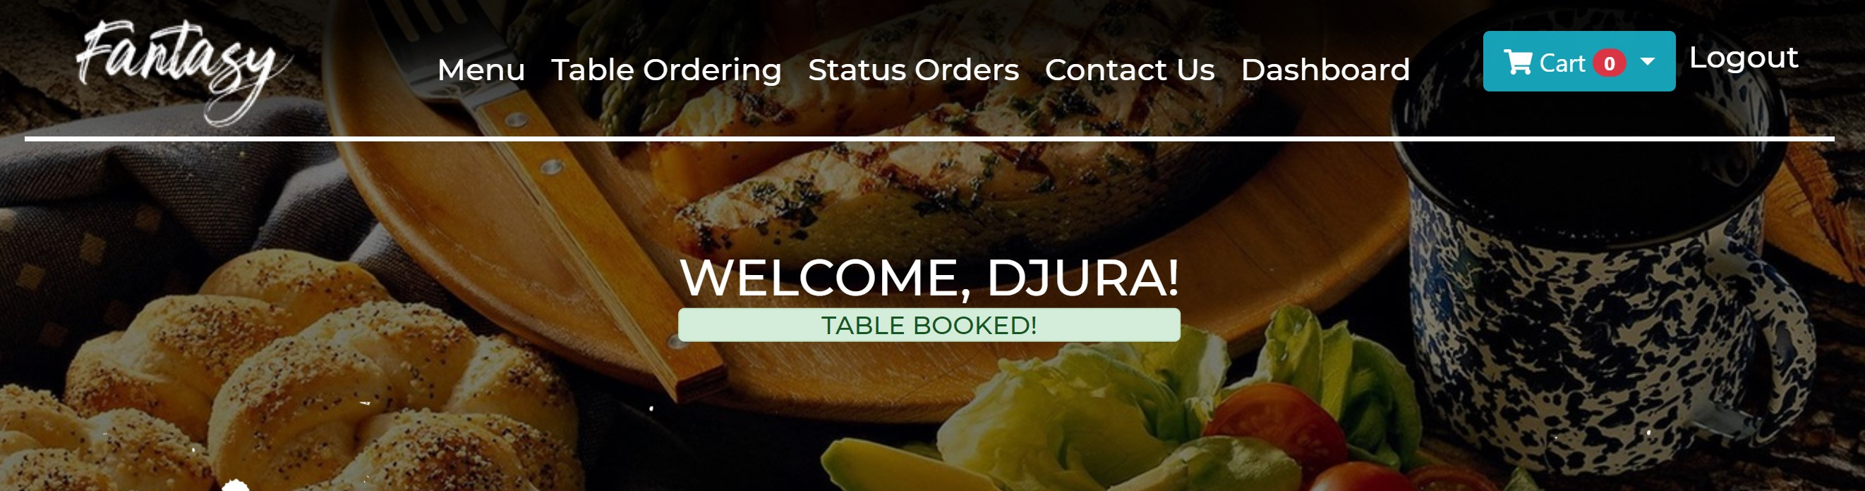

1. **Status Orders –** here user can see his/her food and table orderings which haven’t processed by admin of the site. When user presses “Status Orders” menu it redirects user to status.blade.php and shows the page below.

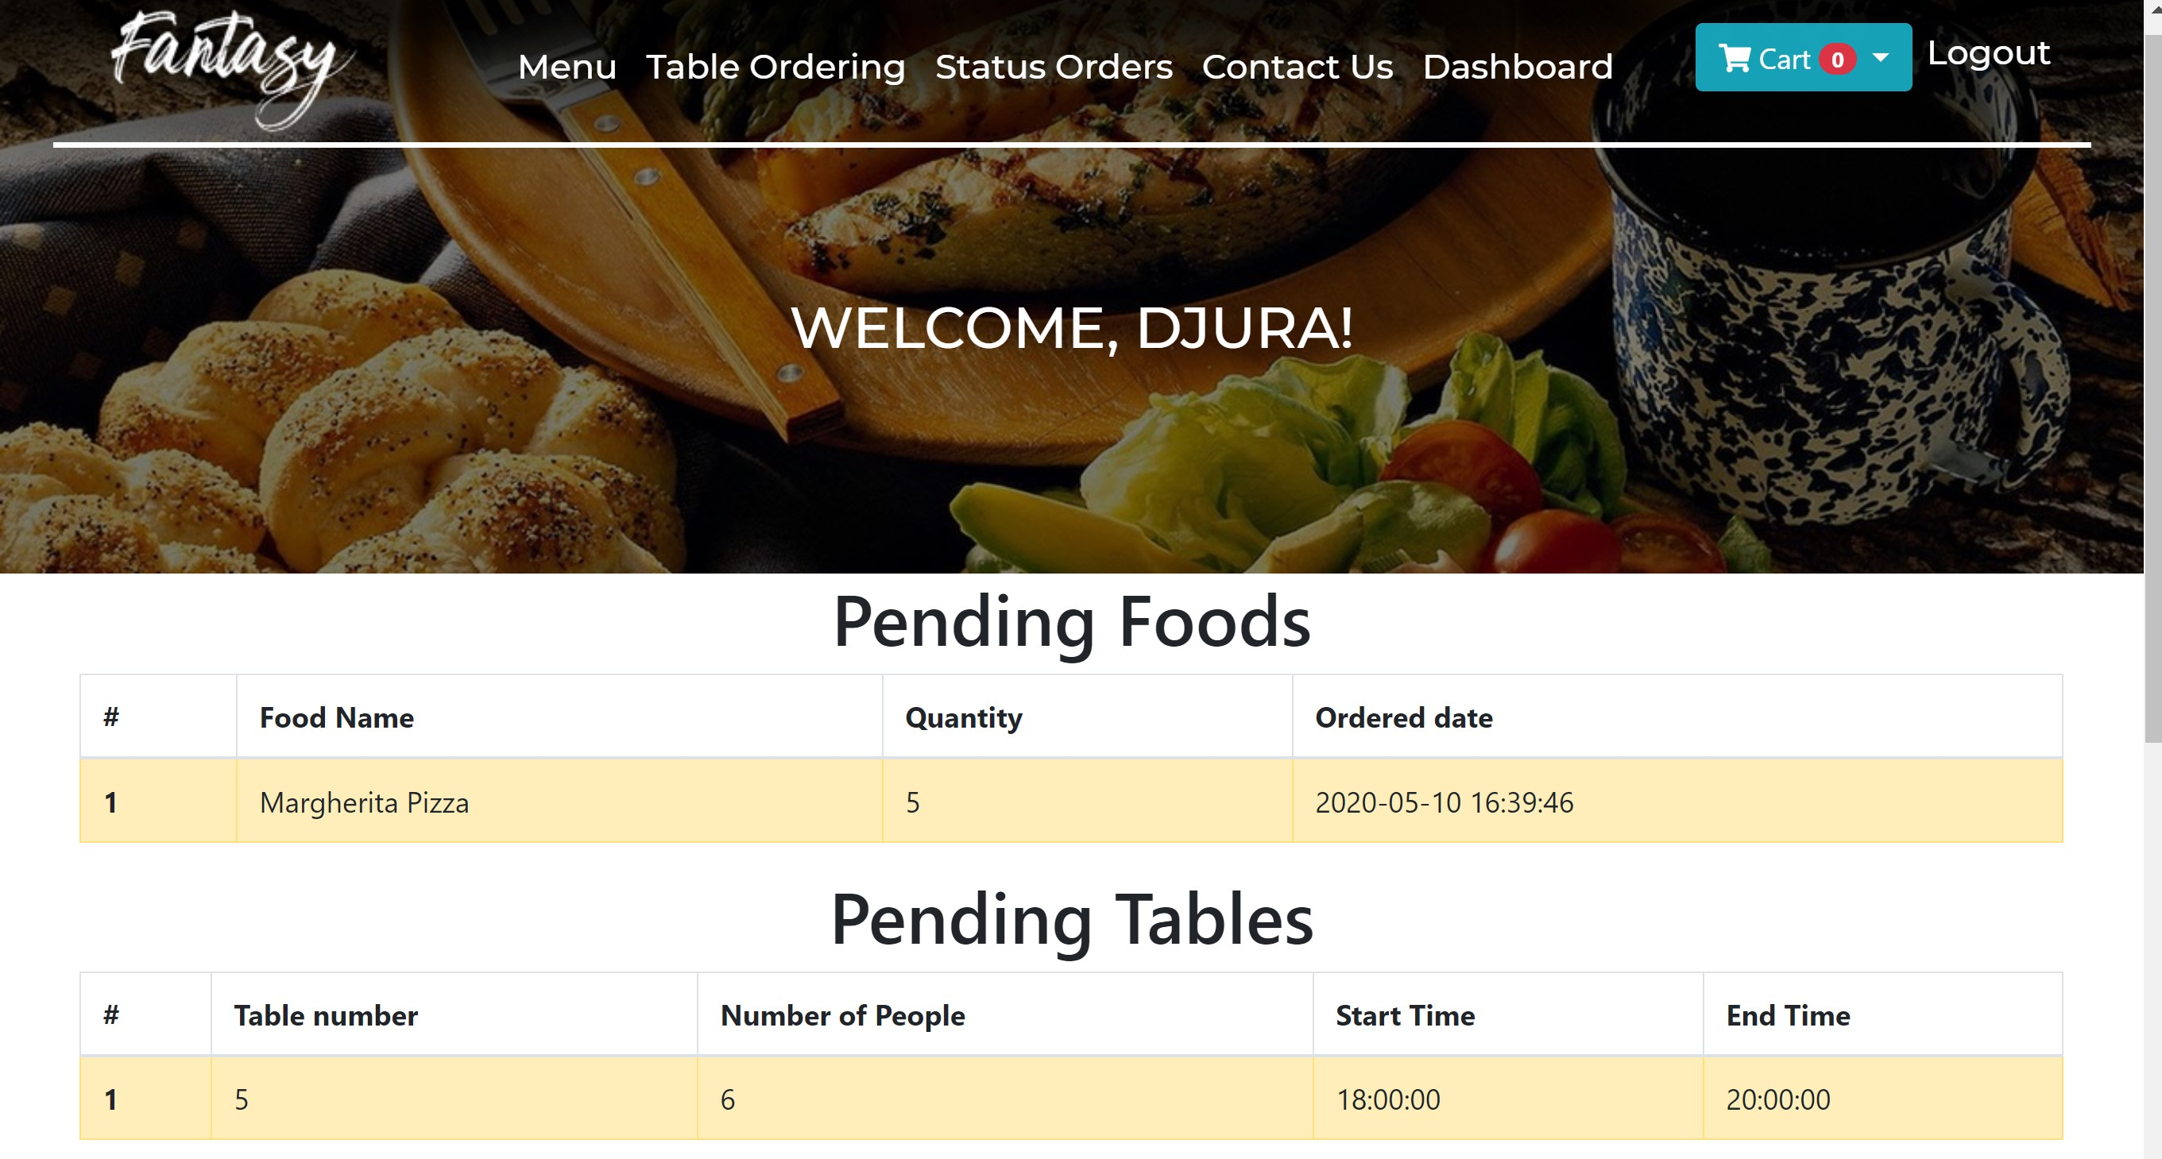

1. **Contact Us** – this button shows the pop-up menu of the feedback part to the guest. When it pressed it goes to sendEmail route with post response and from there it finds appropriate function sendEmail from PostsController. There the message will be sent to site’s admin, more precicely to [info@perfectmix.uz](mailto:info@perfectmix.uz) from the user.

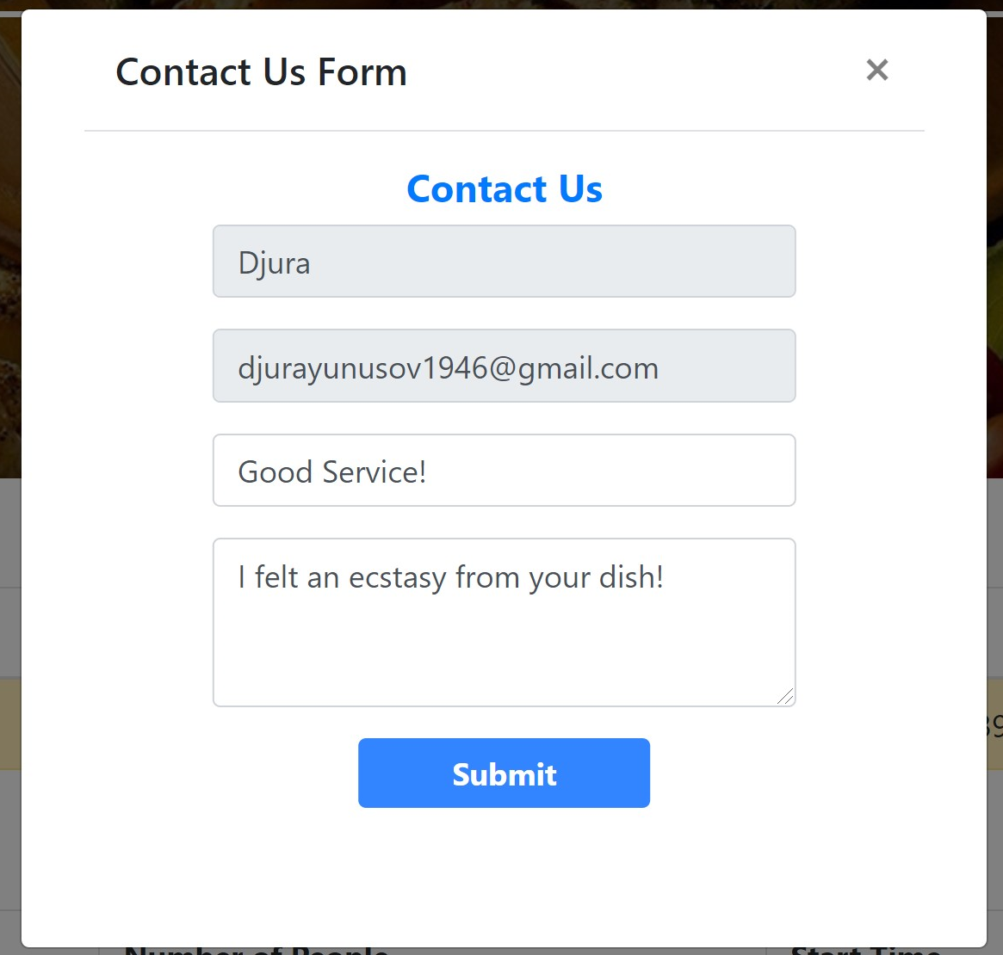

When user presses “Submit” button it redirects route to dashboardIndex with info “Message successfully send!”

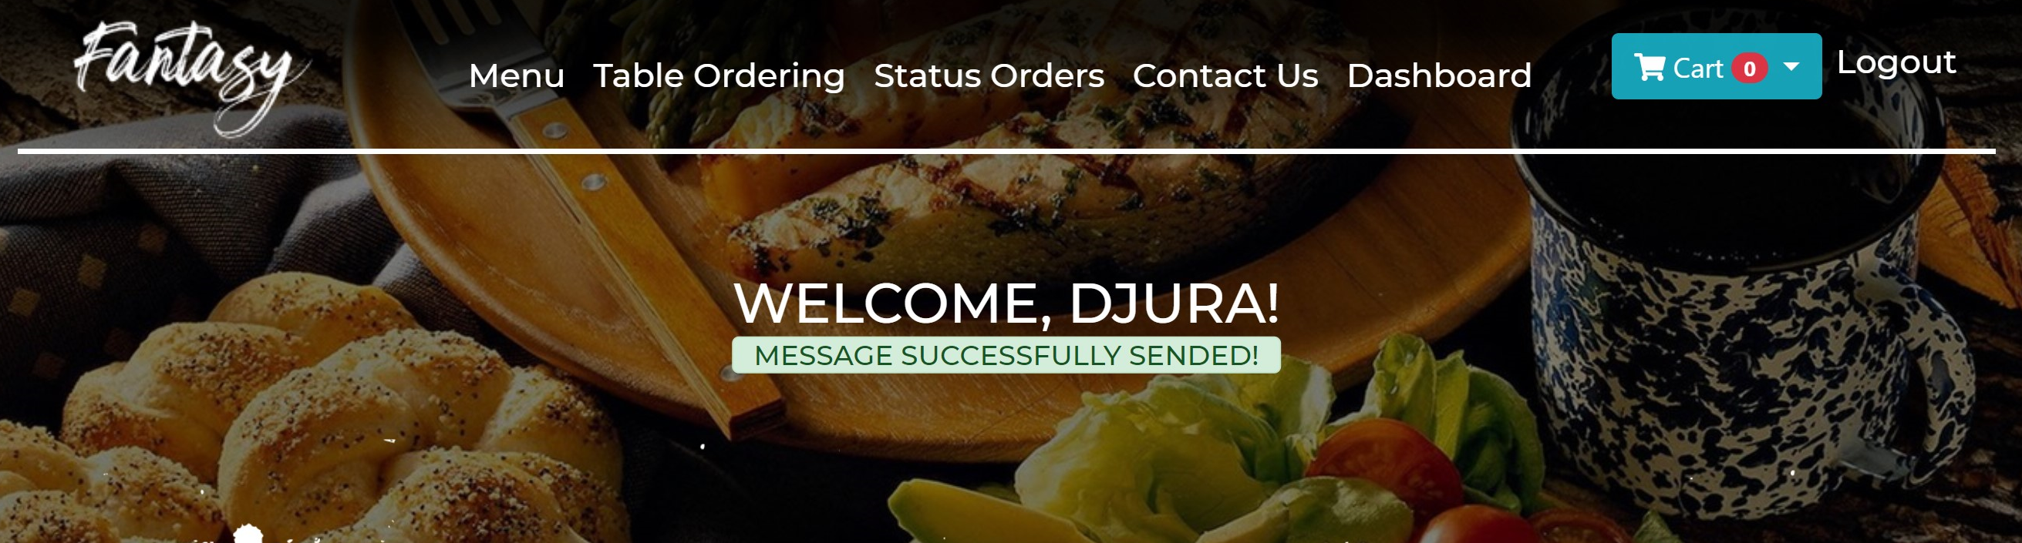

1. **Dashboard** – this is main page of the user which most of the actions redirects at the end. Here user can see his/her orders and edit personal information if necessary.

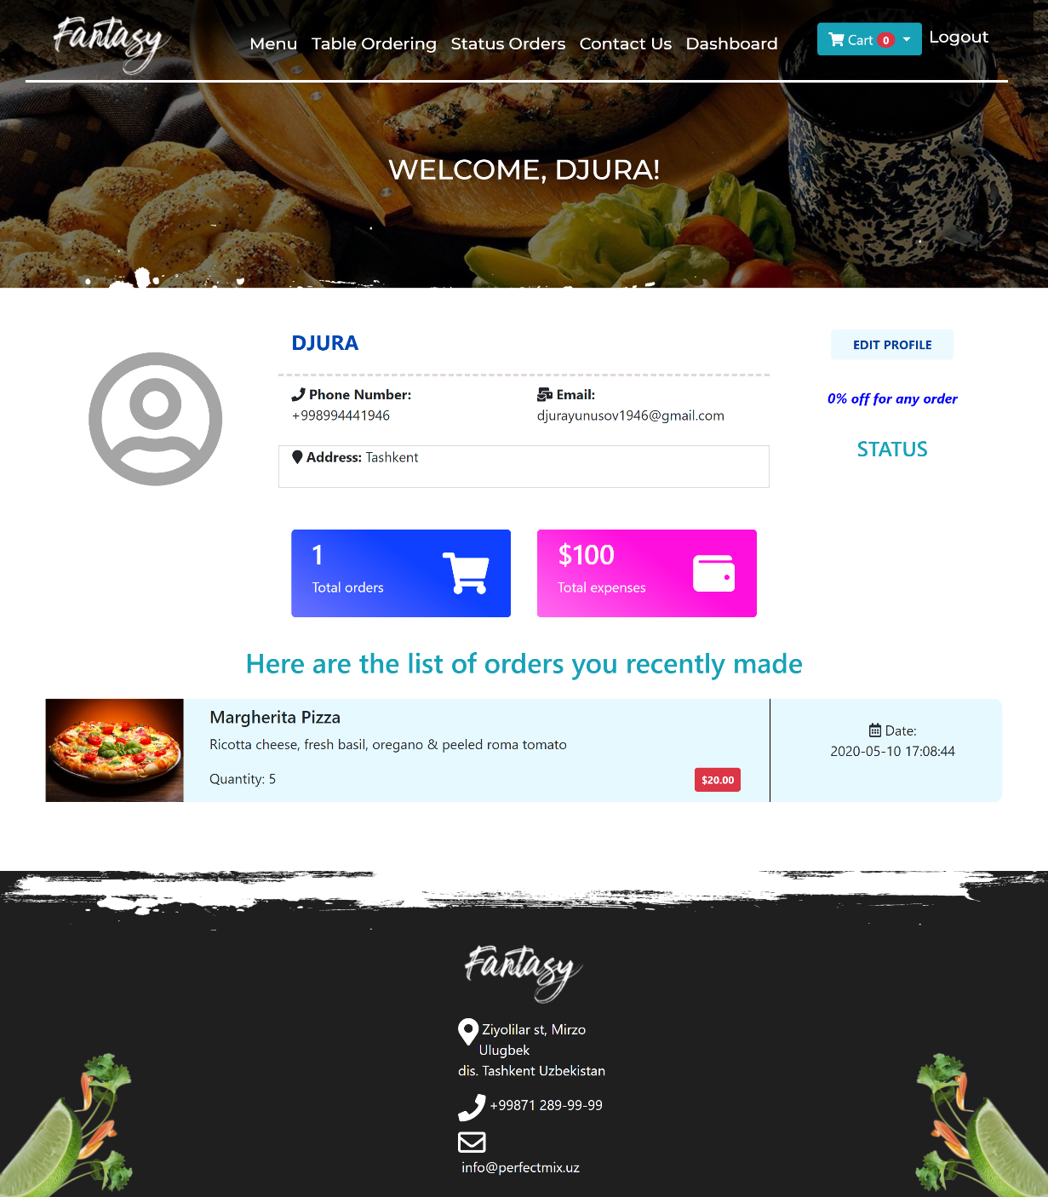

When user presses “Edit Profile” button it sends getUserEdit response to PostsController and awakes getUserEdit function. After which editing has finished, user sends postUserEdit response with post method by clicking “Save” button.

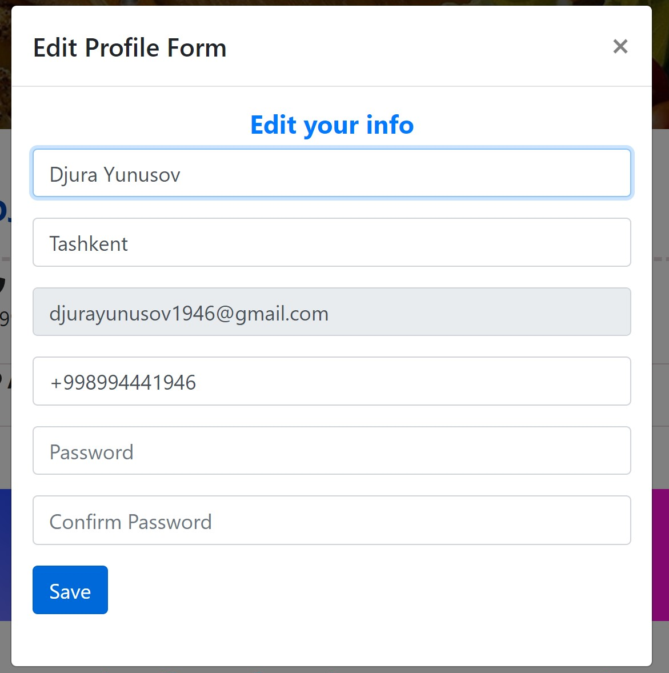

When user presses “Save” button it redirects route to dashboardIndex with info “Successfully updated!”

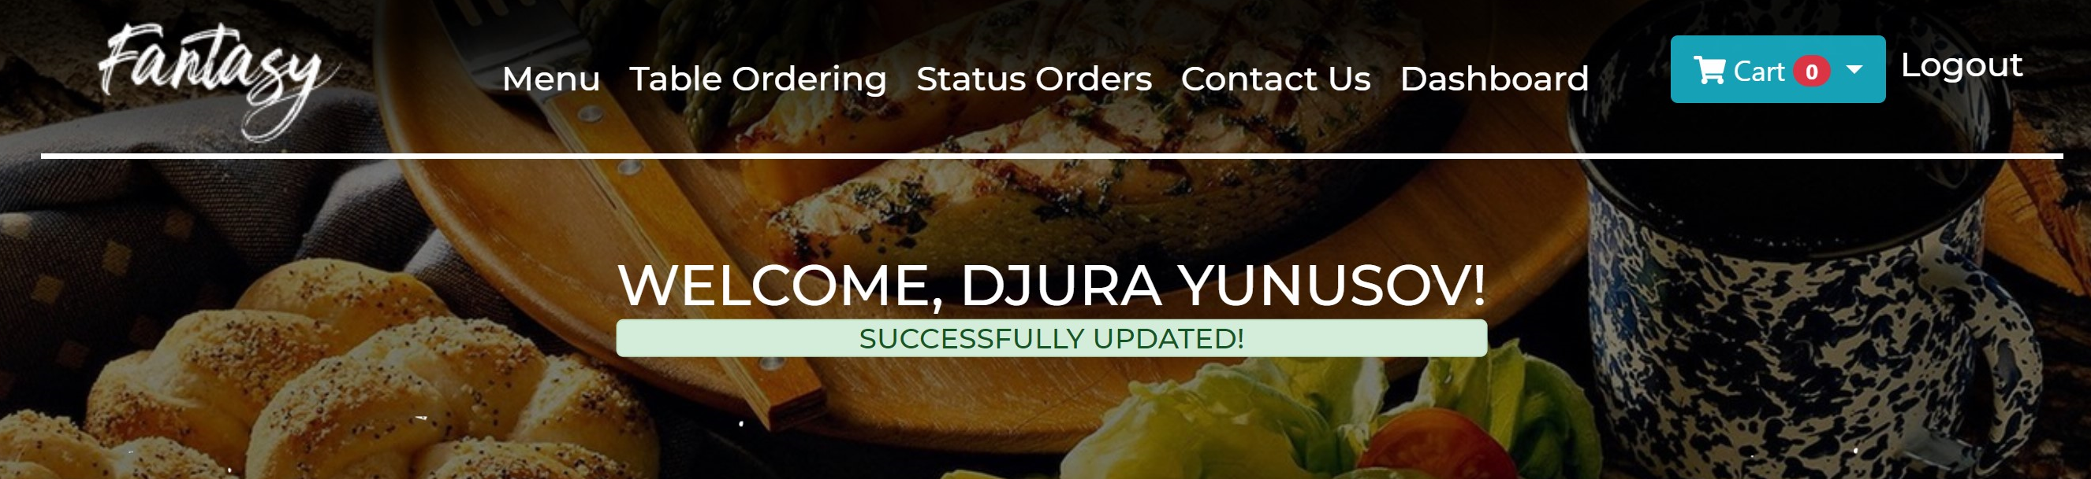

1. **Logout –** redirects to landing page as guest. When user presses this button it redirects user to index.blade.php with guest role.

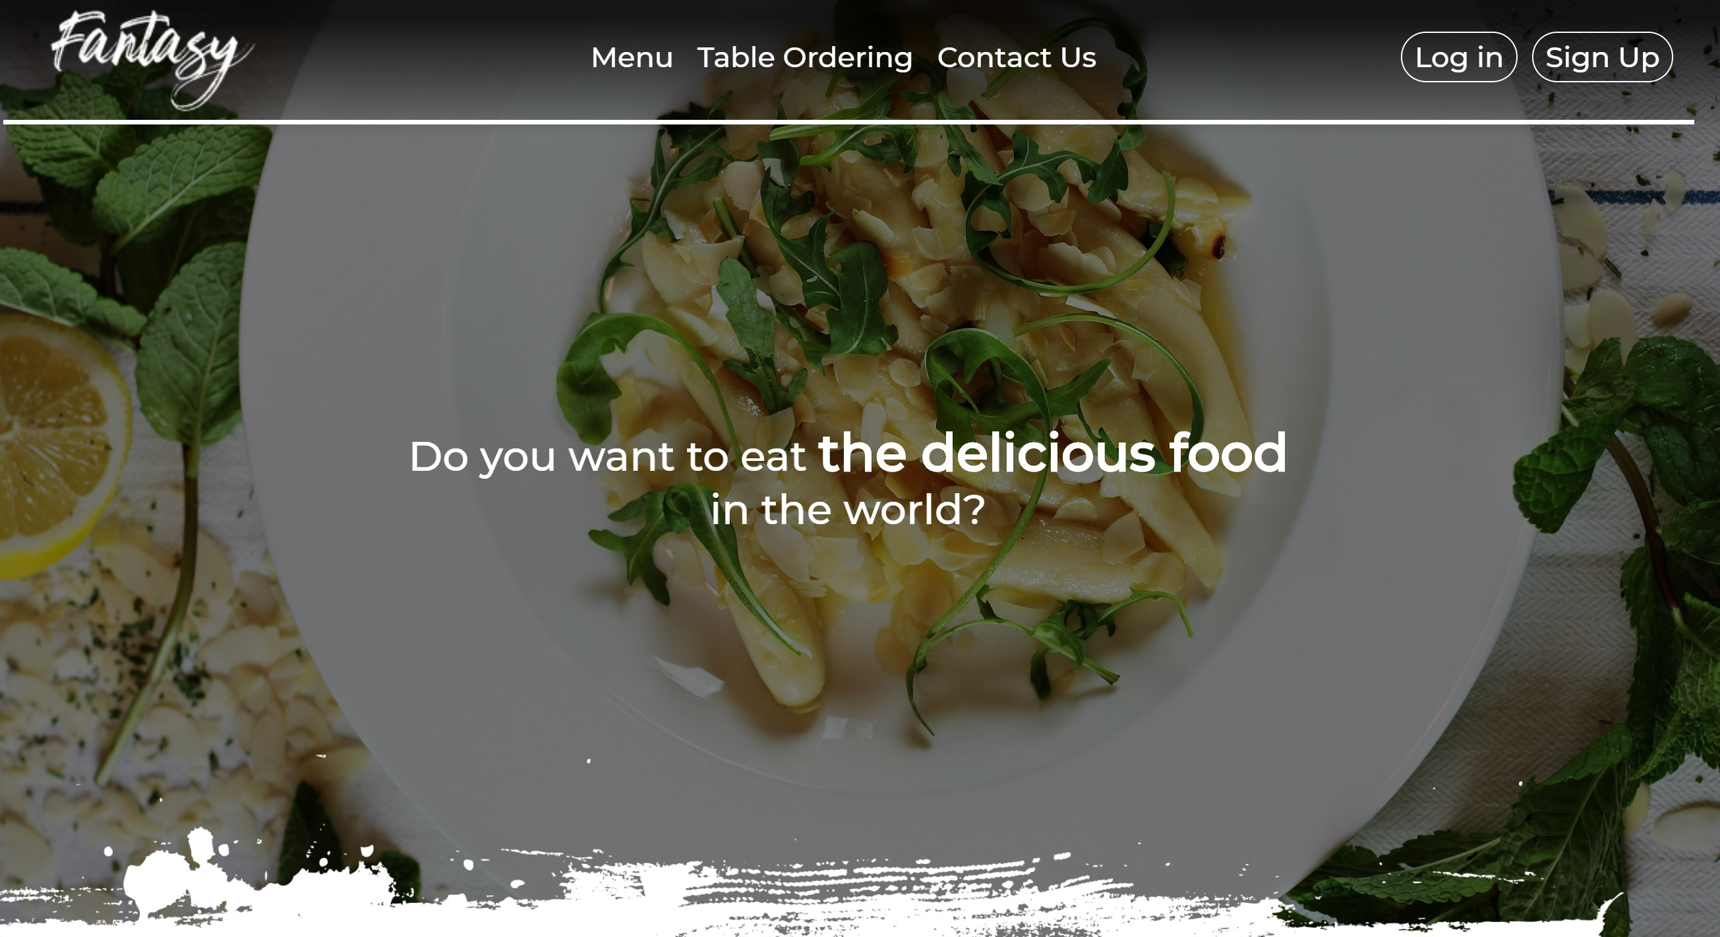

1. **Admin – Person who can control the site**



1. **Admin Panel** – dashboard of the admin page. When admin presses this button it redirects the page to dashboardIndex with get response and from there it finds appropriate function getDashboardIndex from PostsController. There this function clarifies whether user is admin and shows all appropriate info which is necessary to admin.

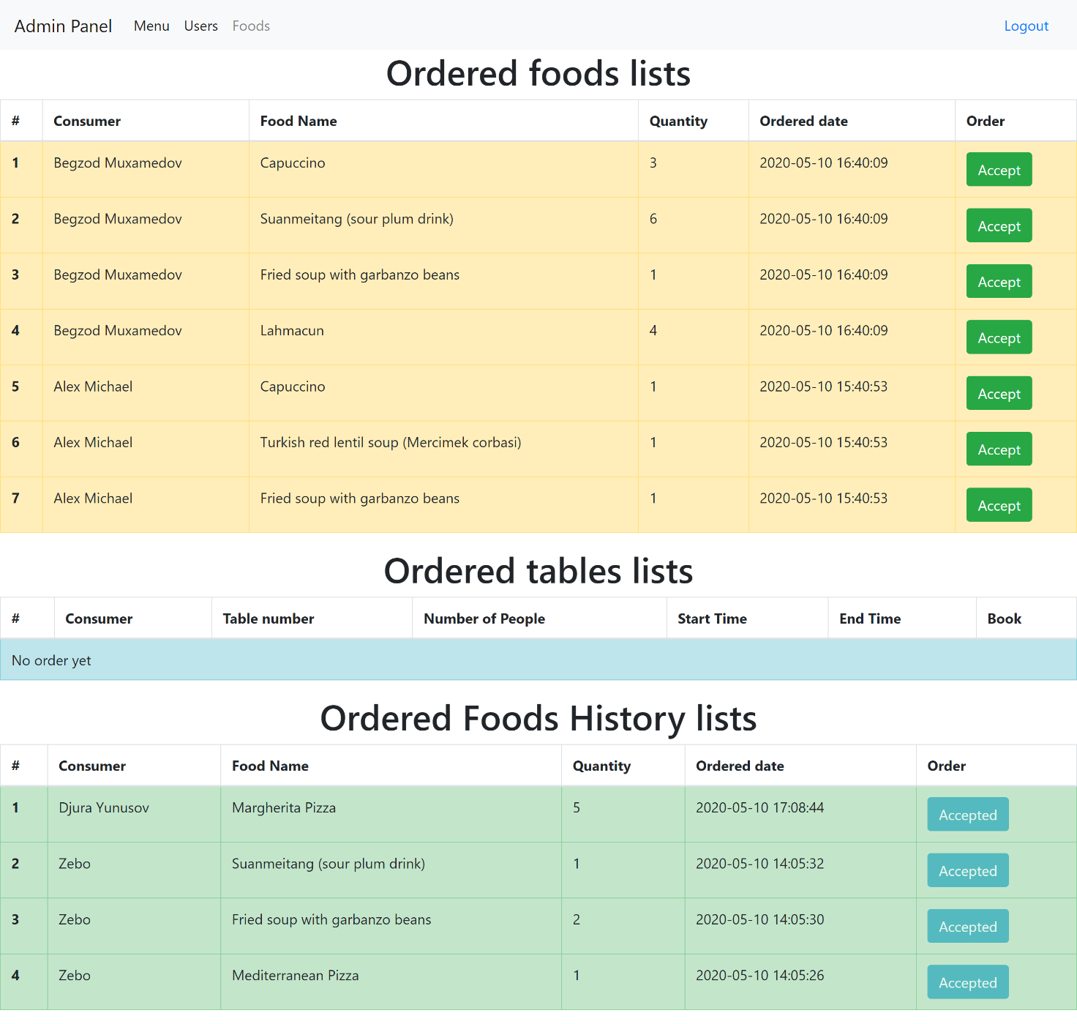

From this list admin can see Ordered Foods and Tables lists, and Ordered Foods History. All these notes will be written in tables, order_histories and order_procceses tables of the database. Admin can see these orders and accept them by clicking “Accept” button. When admin presses “Accept button” in “Ordered foods list” it removes the order with its ID and locates it to “Ordered Foods History lists”. It might be necessary for reviewing the progress of the restaurant.

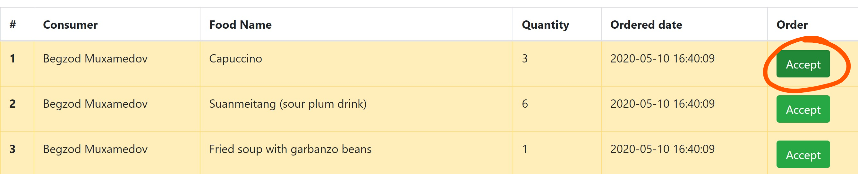

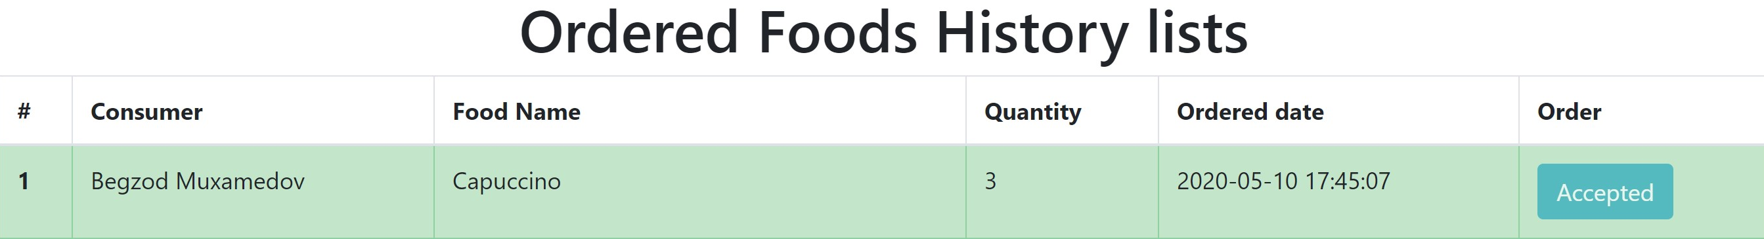

The same action happens in “Ordered tables list”. The difference is, it doesn’t remove the order with its ID, but it deletes from database and doesn’t locates to any history list. Because it is not necessary for restaurant to know about statistics of the ordered tables.

1. **Menu -**  this button redirects to the menu page. This button in admin page works exactly like users’ page. When this button is pressed it goes to the menuIndex route with get response and from there it finds appropriate function in FoodsController which is named getMenuIndex and shows menu.blade.php. For admin its’ necessary to see and control their restaurants’ menu.

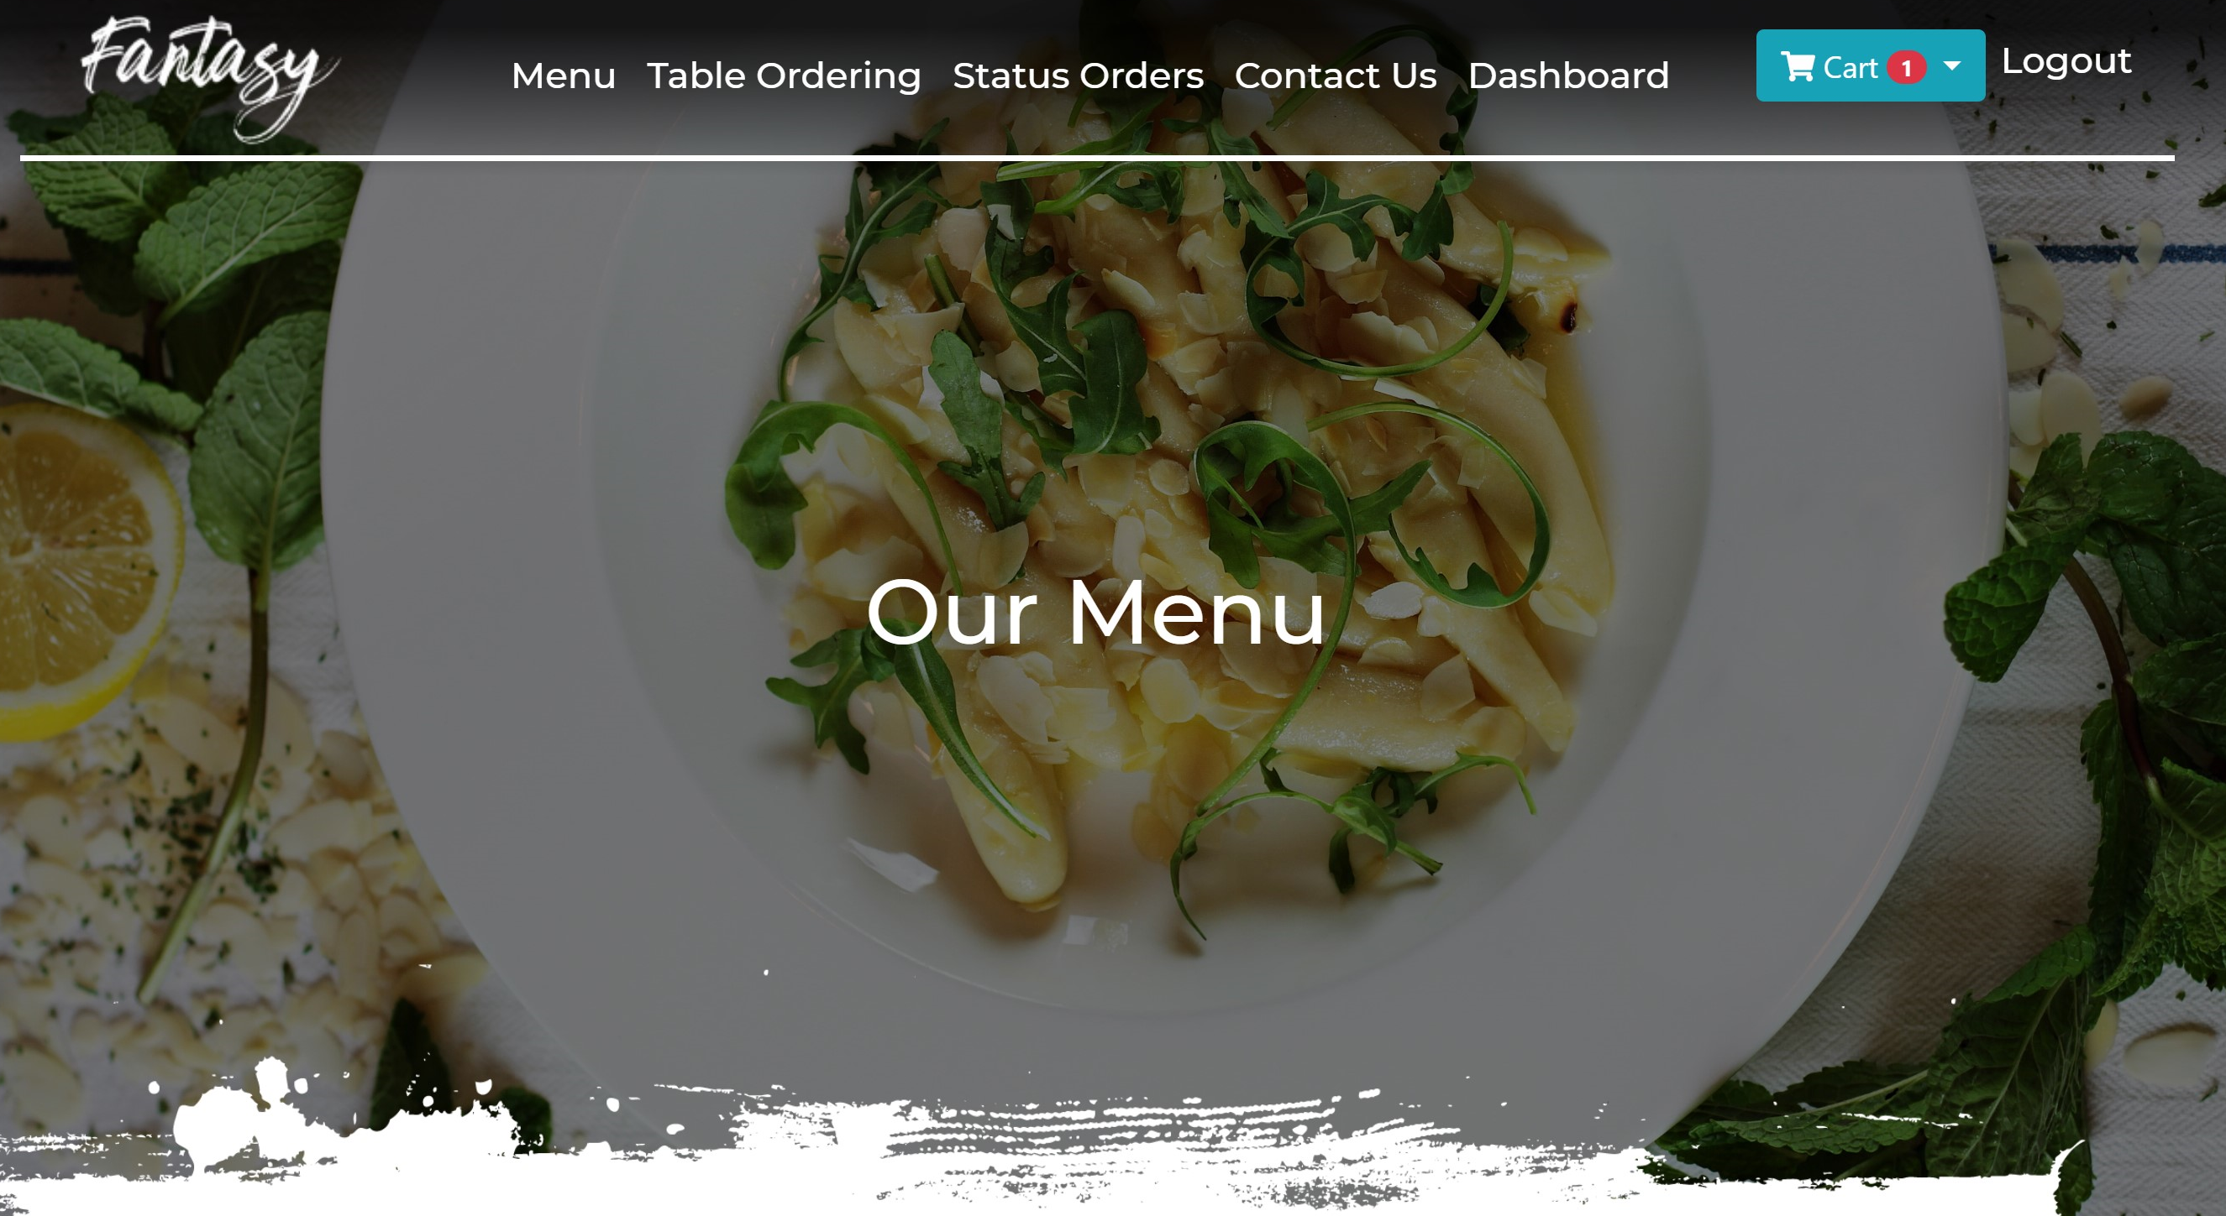

1. **Users** – this page is necessary for controlling all users and admins. From this page admin can add new user by clicking “Add User” button. When admin clicks this button it goes to getAddUser function of PostsController and shows appropriate form.

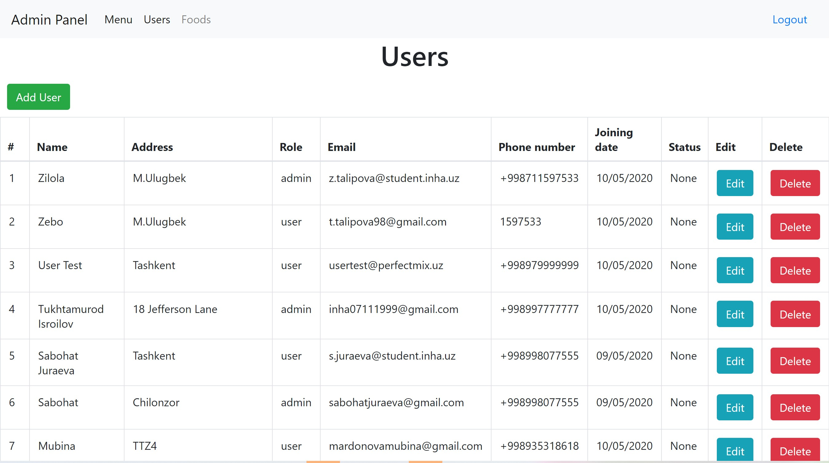

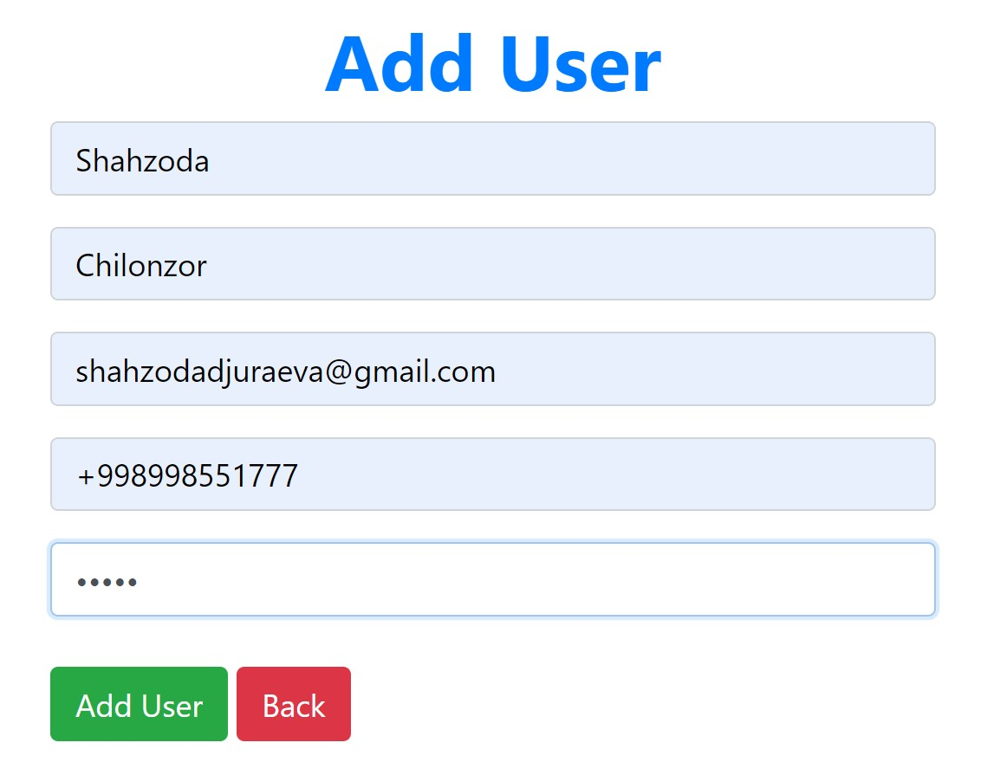

When admin clicks “Add User” button it makes post response to postAddUser function in PostsController and creates a new user, vice versa “Back” button redirects to admins’ dashboard.

Here admin can change users’ role and status by clicking “Edit” button.

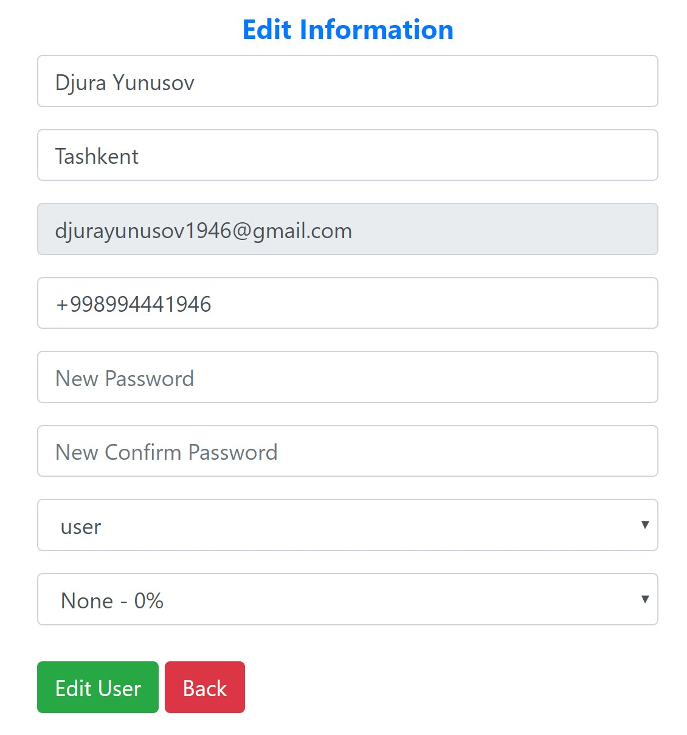

Moreover, admin can choose user or admin role and give a status. According to users’ orders admin can give like a discount for users. It means that if user purchases more than $300 in one order then him/her will be given 3% discount for next orderings; if user purchases more than $500 in one order then him/her will be given 5% discount for next orderings; if user purchases more than $700 in one order then him/her will be given 7% discount for next orderings.

Also admin can delete users or admins if this is necessary.

1. **Foods –** this button is needy for refreshing the menu of restaurant. Here admin can add new types, cuisines and foods. For this admin fill appropriate fields and click add button. These forms in addFood.blade.php will refersh the page when addPostFood requestis sent with post method.

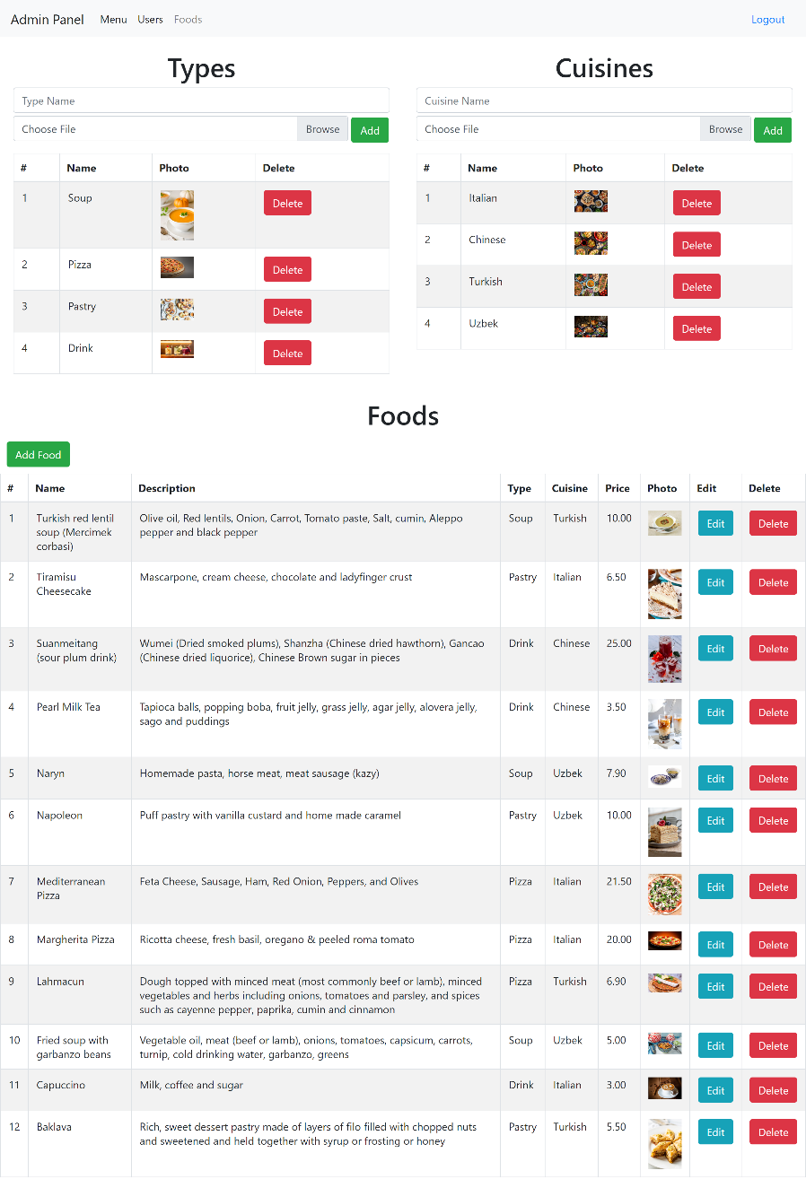

When admin presses “Edit Food” button it redirects to editFood.blade.php. After filling the form with appropriate data and pressing “Edit Food” it goes to editPostFood route with post method in FoodsController and refreshes admins’ dashboard with updated info.

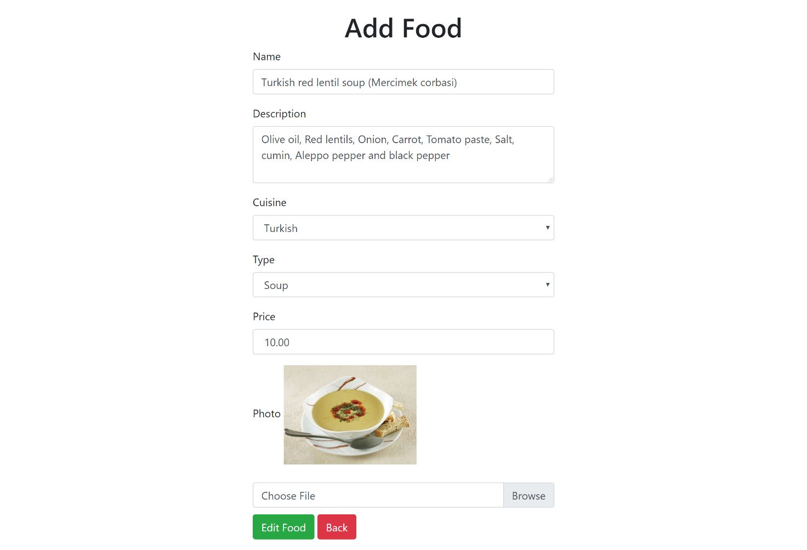

1. **Logout –** redirects to landing page as guest. When user presses this button it redirects user to index.blade.php with guest role.



**Client-side Scripting**

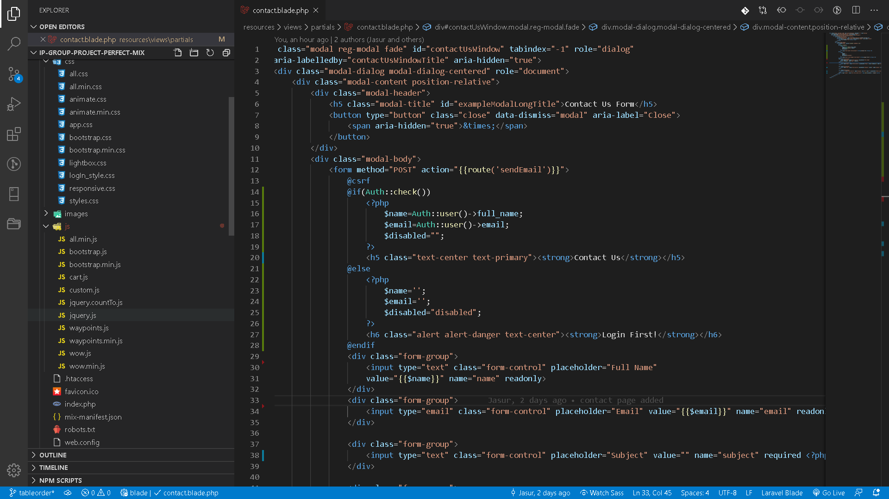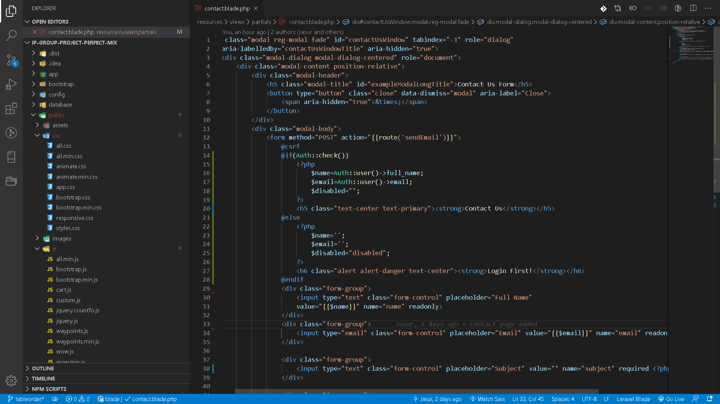

Above the list of js script files and css style sheets we used in our project.

**1. all.min.js** – necessary for fontawesome icons.

**2. bootstrap.js** and **bootstrap.min.js** – necessary js files to use together with bootstrap.css

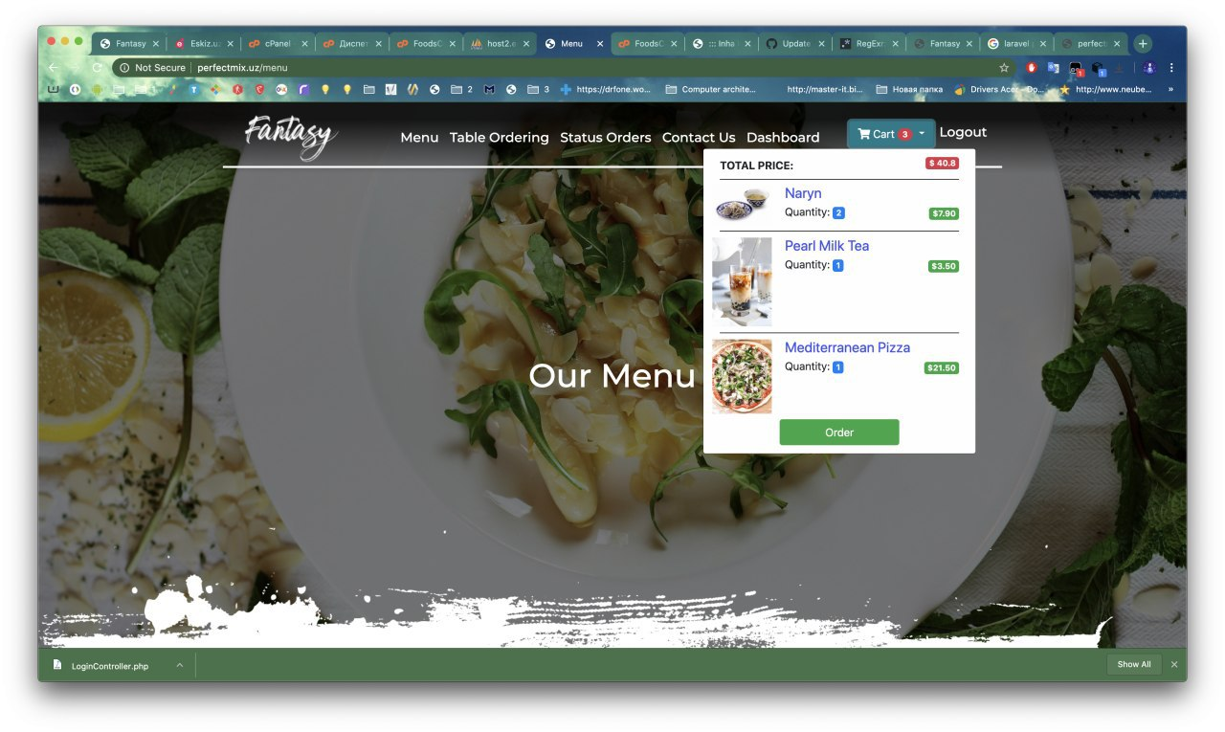**3. cart.js** – a script used to manage cart when shopping. When user presses add to cart this script generates a post request to the server using ajax informing server about that request, and if success

it populates the card menu with the newly added item, if user presses one item twice it simple increments the quantity by the given quantity.

**4. custom.js** – inside custom js you find some helpful things that provides the responsiveness of the menu item images when user resizes the window changing height of the image correspondingly to its width.

**5. jquery.countTo.js** – js package that are used to make animations like counting up to a given value at a specified speed. We used it to when showing user total expanse and orders they made in their dashboard.

It starts to count when it is 90% off the viewport.

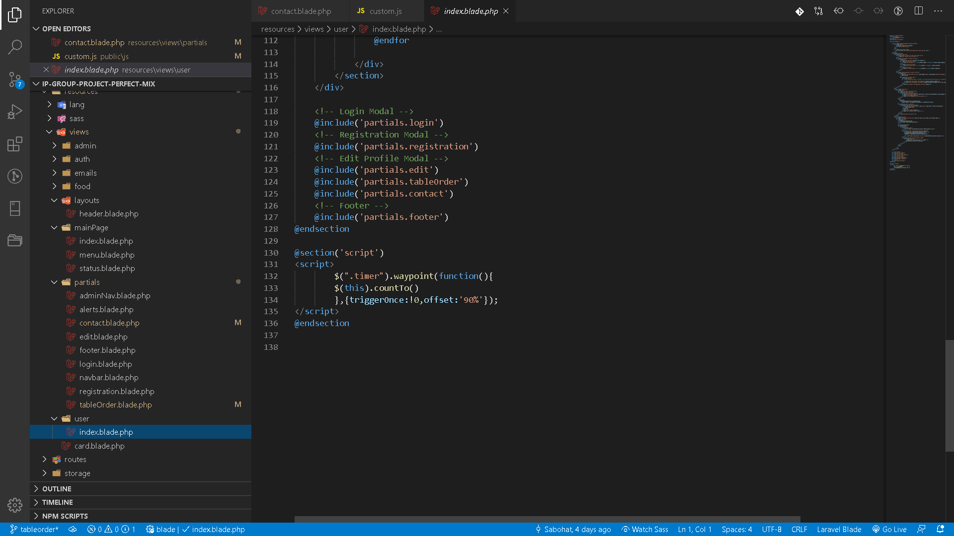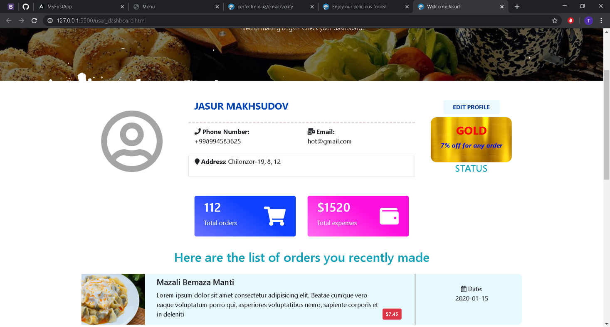

**6. jquery.js** – we used this package to make it easy to HTML DOM Traversal and work with css and additionally make ajax requests.

**7. waypoints.js** and **waypoints.min.js** – used to trigger events in elements when they are in a particular place of the viewport. Particularly we used it trigger counting.

**8. wow.js** – js package used with animate.css together to make animations simple by just adding specific classes and attributes to HTML elements.

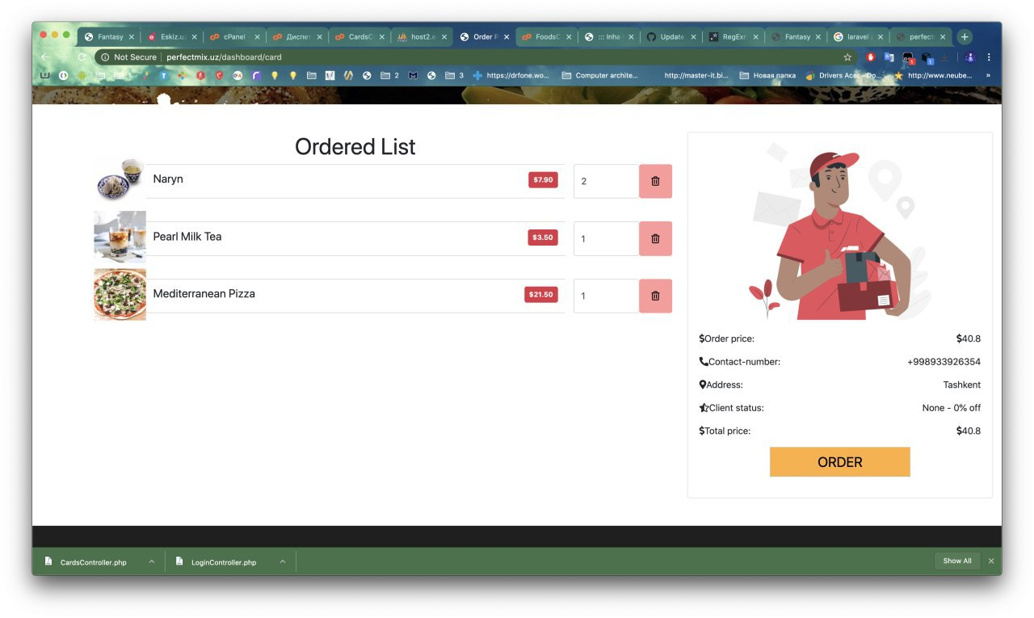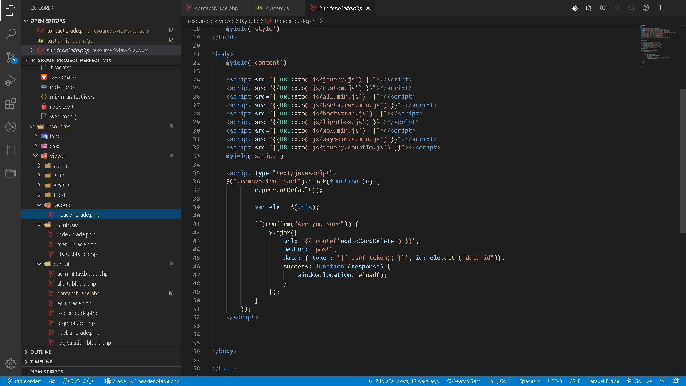**\*** This script generates ajax request when user tries to delete an element from the cart in order page informing server about this change since all the order details are controlled in userSession in the serve

**GitHub and Hosting**

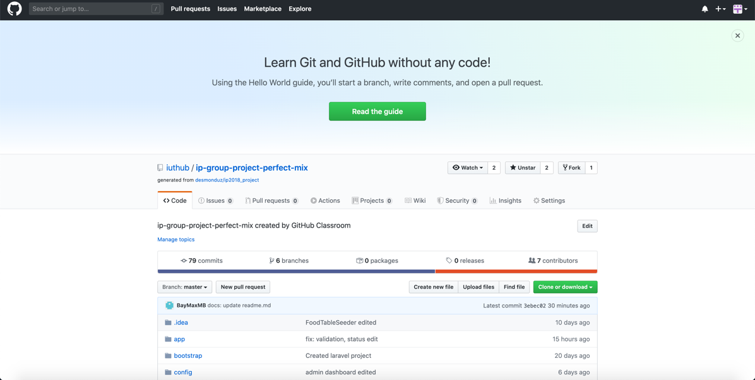

**GitHub** brings together the world's largest community of developers to discover, share, and build better software. Collaborating with teammates and deploying our web application, we used the tool GitHub. We made pushes and commits for our work. You can see our commits here: <https://github.com/iuthub/ip-group-project-perfect-mix/commits/>

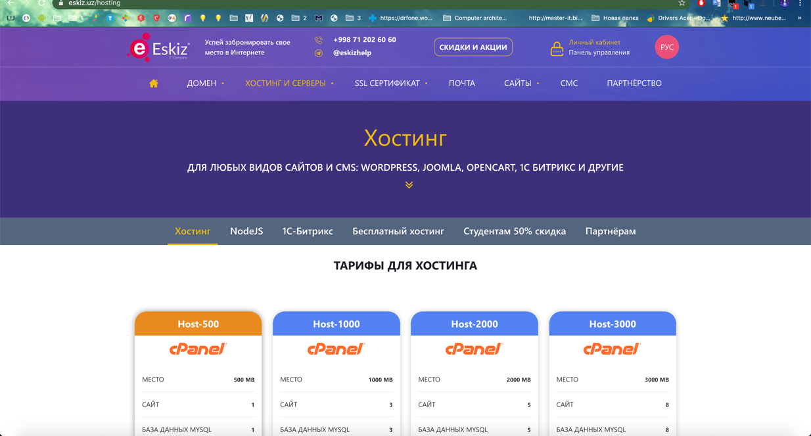

We also uploaded and configured our web application to Eskiz company’s hosting. We worked with cPanel for uploading project, set up MySQL database and SMTP server for email verification and email sending. You can see our web page: <http://perfectmix.uz/>

Account for Admin :

Email: admintest@perfectmix.uz

Password: perfectmix

Account For User :

Email: usertest@perfectmix.uz

Password: perfectmix

**Conclusion**

**Jasur:** The main contribution was in the backend part, created the Laravel project, according to the designs connected them to the proper locations, edited and filled with functions of database, authentication, worked with controllers and their relations with database, divided into roles – admin, user and guest, populated all necessary information, worked with hosting and all relational admin functions.

**Sabokhat:** The main contribution was in creating food pages for admin controller, created add and edit of food for restaurant, worked in population of admins, fixed some relational changes in database and filled the site with appropriate menus, cuisines, types and foods.

**Mubina:** The main contribution was in creating of database to the project, worked with connections and relations in database side, edited admin panels necessary features and updated them, fixed some problems in checkout and some relational changes.

**Bekzod:** My main contribution to this project was to make dashboard (add, delete, edit products, food types, users) for admin users, dashboard, order making pages and process for users, edit forms, feedback sender form and validations, editing user statuses (silver, premium, gold) and minor edits to readme file

**Tukhtamurod:** I mainly did the front end part of the project like pages, css styles and js. To be more precise, we worked synchronously with the team, for example Zilola Talipova made the design of the page using third-party tool and using this design I created the actual form of the page along with styles, we did the css part of the project with Zilola Talipova using Bootstrap and custom css, Bekzod did the food ordering page and user dashboard content and I gave it a “look and feel” styles, I mainly used Bootstrap to for layouts and for the sake of responsiveness but 90% of the style was done by pure css. I also made an asynchronous call to the server to at some points using ajax, for example when adding foods to cart.

**Zilola:** My part of the project is designing the website then coding it.

At first I started designing webpages in figma artboard, and logo and other picture are created by me. I fully coded menu page and also main page and login registration is coded, but then discussing this page with out team we decided to change login registration page from single page to popup page, and also main page recoded by Tuktamurod